**COMBINED NATIONAL CHAMPIONSHIPS**

**2018 at GOSFIELD LAKE**

Wednesday 25th July to Sunday 29th July

**INFORMATION BULLETIN**

We look forward to a great combined National Championships at Gosfield Lake,. and hopefully the schedule, which we have given a lot of thought and time arranging, will be acceptable to all. The idea behind it is to make a better competition that encompasses all age groups and brings the whole sport together creating a greater atmosphere and sense of occasion and giving the Nationals the standing it deserves and the competitors the kudos from skiing in it against the best in the country.

We look forward to your support and would hope that you’ll enjoy being a part of this tournament, be assured we are doing this to try and improve competitive water skiing and the number of competitive water skiers within our sport.

**BOATS & PRACTICE**

Nautique Boats will be the official towboat and practice behind these boats will be available before the tournament at members rates – book and pay by calling 01787 475043. On Monday 23rd, normal ski times will be available, however on Tuesday it will be short practice tows – 4 slalom, 2 jumps, 2 runs of tricks, to allow for maximum amount of competitors to get a practice - £15.

**QUALIFYING STANDARDS**

The qualifying standards for the British National Open, Youth and 35+ Championships are available in the **BritishTournament Additional Rules 2018** which are available on the resources section of the BWSW website in the resources section (you will need to register and login to the website to access the resources section). Any skier, Youth U21, or 35+ can qualify for the open finals for tricks and jump based on their preliminary round score as long as they have entered the open as well as their age category. But slalom skiers who do not shorten at the Open speeds cannot be considered for the open final

**SCHEDULE OF EVENTS**

A provisional outline schedule for the Championships has been supplied to help competitors with their planning.

However, this is NOT definitive and the schedule may need to be adjusted depending on weather conditions and number of entries. There will be a Facebook event for all those on Facebook and will be updated regularly, if not on Facebook, please advise us of your email, so that we can keep you updated.

**FOOD**

Delicious by the Lake will be serving hot & cold food throughout the competition

The Apple Tree is our licensed onsite restaurant would suggest booking.

Friday Evening : There will be some presentations on Friday evening by the lake along with a catered BBQ at £12 per head. Bring your own drink and entertainment will be provided. Please contact Emma at [emma@theturps.co.uk](mailto:emma@theturps.co.uk) to book as the food will need to be pre-ordered.

.

The rest of the presentations will be held on Saturday or Sunday once the competition is complete.

**ACCOMODATION IN THE LOCALITY**

**Self-Catering Cottages** Tel: Distance from lake - miles

Brickwall Farm 01787 460329 2

Panfield House 01376 326345 4.3

Ballaglass 01376 331409 3.9

Gt Lodge Farm 07834 044280 4.5

Castle Hedingham 01787 463791 3.7

The suites@pannells 01787 463127 5.4

Watermill Cottages 07974 669378 6.4  
The Granuary 01371 810315 8.5

**Hotels**

Bull Hotel 01787 472144 1.8

Dog Inn 01787 477774 2

The Dorrington 01787 477754 1.7

Hare and Hounds 01376 325436 1.8

Premier Inn B’tree 0871 527 8138 4.7

Premier Inn F’port 0871 527 8140 4.8

Holiday Inn 0871 423 4828 5.3

**B & B’s**

Meadway 01787 472858 0.5

Lynton House 01371 850975 3.8

Castle View House 01787 827341 3.7

The Green 01376 851643 4.6

**CAMPING** Gosfield Lake has purpose built toilet and shower block, laundry room & washing up

facilities, competitors will be able to camp, electric hook up can be available, please book asap, to receive discounted rate please call 01787 475043.

**ENTRY FORMS**

The entry form is attached.

■ Return the completed form labelled ‘Competition Entry to Gosfield Lake Water Ski Club, Gosfield Lake, Church Road, Gosfield, Essex. CO9 1UD Tel: 01787 475043. E-mail emma@theturps.co.uk

■ The procedure for acceptance of entries as detailed in the Tournament Additional Rules will be applied for this competition.

■ **CLOSING DATE FOR ENTRY MONDAY 16th July 2018**

**ENTRIES WILL NOT BE ACCEPTED WITHOUT PAYMENT.ENTRIES RECEIVED AFTER 16th July 2018 WILL NOT BE ACCEPTED UNLESS SPACE PERMITS IN WHICH CASE THEY MAY BE ACCEPTED WITH AN ADDITIONAL LATE ENTRY FEE OF £25**

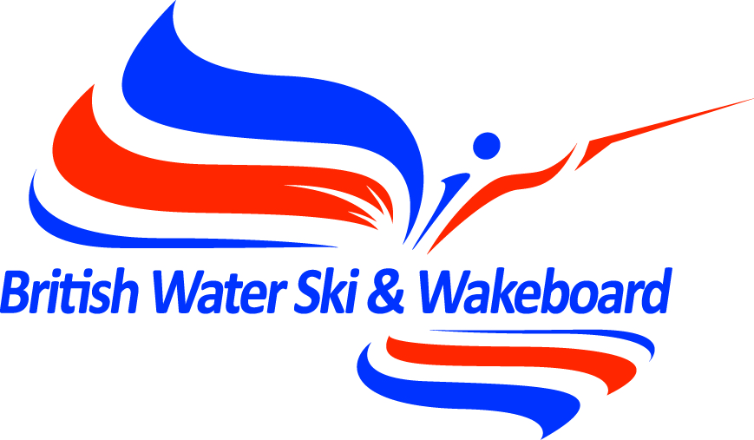

## The British National Tournament Championships 2018

## GOSFIELD LAKE, ESSEX 25th – 29th July

##### OFFICIAL ENTRY FORM

|  |  |  |  |
| --- | --- | --- | --- |
| **Surname** |  | **Forename(s)** |  |
| **Address** |  | | |
| **Home phone** |  | **Mobile** |  |
| **Email** |  | **Date of birth** |  |
| **Membership No.** |  | **Age Cat Entered** |  |

**EVENTS –** Skiers who qualify for two events may enter the third. Tick which events you wish to enter.

|  |  |  |  |  |  |  |
| --- | --- | --- | --- | --- | --- | --- |
| **Slalom** |  | **Tricks** |  | **Jump** |  | **Jump Height** |
| **35+** |  | **35+** |  | **35+** |  |  |
| **Open** |  | **Open** |  | **Open** |  |  |
| **Youth** |  | **Youth** |  | **Youth** |  |  |
| **Age Cat & Open** |  | **Age Cat & Open** |  | **Age Cat & Open** |  |  |

My Current best performances are:

Slalom Tricks Jump

## ENTRY FEES

|  |  |  |  |
| --- | --- | --- | --- |
|  | **Entry Fee** | **Additional Open Fee** | **Fee enclosed** |
| **One Event** | **£50.00** | **£5.00** |  |
| **Two Events** | **£100.00** | **£10.00** |  |
| **Three Events** | **£120.00** | **£15.00** |  |
| **Total Payment Enclosed – credit card details can be given overleaf** | |  |  |

Enclose the entry fee as per table, if a skier wishes for their preliminary score to count for the Open Nationals there will be an additional entry fee of £5.00 per event.

British Water Ski & Wakeboard can accept no responsibility for the accuracy of information distributed on any clubs behalf nor guarantee that any club will accept entries on application forms other than those distributed by the clubs. Entrants are therefore strongly advised to confirm with the event organiser that their entry has been accepted.  
**⇨ Please turn over to complete your entry form**

|  |
| --- |
| * I wish to enter the British National Championships 2018 in the events shown on this entry form * I am in possession of a current Tournament Licence. * I am a current member of British Water Ski & Wakeboard. * I have read and understood the Tournament rules * I have read and understood the British Water Ski & Wakeboard Code of Conduct and agree to abide by it * I undertake to save harmless and keep indemnified BWSW, the organising club and their officials from and against all claims in respect of injury caused to my person or property in connection with my entry.   SIGNATURE _____________________________________________ DATE _______________________ |

