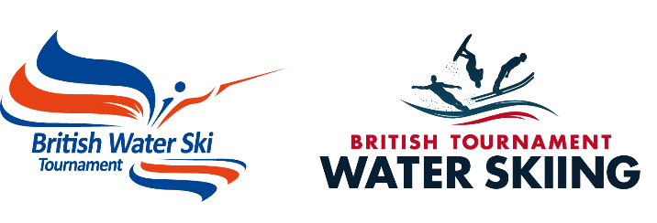

The British Combined National Tournament Championships 2019

Age Cat & OPEN run by PWTC at

Hazelwood Ski World, Lincoln

Thursday 22nd to Monday 26th August 2019

information bulletin 1
We look forward to a splendid combined National Championships at the home of Hazelwood Ski World, Thorpe on the Hill, Lincoln sponsored by RADAR SKIS. With the new opening of Lincoln Water Park (Lincolnwaterpark.co.uk) on the far side of the ski lake, there will be plenty of fun for all the family this year. There will be various food options on some evenings, details will be posted nearer the time.

QUALIFYING STANDARDS
In order to enter either the Age Cat, Open or both then the skier must ensure they have achieved the minimum Qualifying standards, as listed in the British Additional Rules. Any Age Cat skier wishing their Preliminary score to count towards the Open must ensure they have achieved the qualifying standards as per the Open qualifying standards.
The qualifying standards for the British National Open, and Youth Championships are available in the British Tournament Additional Rules 2019, which are available on the resources section of the BWSW website in the resources section (you will need to register and login to the website to access the resources section) or www.tournamentwaterskiing.org.uk. There are no qualifying standards for the 35+ Championships. Any skier, Youth U21, or 35+ can qualify for the open finals for tricks and jump based on their preliminary round score as long as they have entered the open as well as their age category. However, slalom skiers who do not shorten at the Open speeds cannot be considered for the open final.

Schedule of Events
Below is the PROVISIONAL timetable. The British U14 & U17 Team will be leaving for the Youth European Championships on the Saturday, so their finals are going to be finished by Friday night. This timetable is subject to change, depending on number of entries.

Thursday 22nd
- U14 & U17 Prelims

Friday 23rd
- Youth Slalom Prelims (U10,U12 and U21)
- All Youth Trick Prelims (U10,U12 and U21)
- All Youth Jump Prelims(U10,U12 and U21)
- U14 & U17 Finals
- PRESENTATION OF U14 & U17 MEDALS- SPONSORED by RADAR

Saturday 24th
- U10, U12 & U21 Trick Finals
- U10, U12 & U21 Slalom Finals
- U10, U12 & U21 Jump Final
- RADAR SKI LAUNCH
- Possible Senior & Open Trick Prelims
- RADAR 4 BUOY Challenge on the back lake.
- PRESENTATION OF U10, U12 & U21 MEDALS- SPONSORED by RADAR

Sunday 25th
- Senior Slalom Prelims
- Open Slalom Prelims
- Senior Jump Prelims
- Open Jump Prelims
- LAUNCH of NEW Radar SKI
- Senior Trick Prelims or Finals
- Open Trick Prelims or Finals

Monday 26th
- Senior Trick Finals (if not completed Sunday)
- Open Trick Finals ( if not completed Sunday)
- Senior Slalom Finals
- Open Slalom Finals
- Senior Jump Finals
- Open Jump Finals.

However, this is NOT definitive and the schedule may need to be adjusted depending on weather conditions. Any changes to the schedule will be posted on the official noticeboard on site and on the live results on line. However the only official notification will be the Notice Board.

Boats
Malibu Boats will be the official towboat and official practice behind these boats will be available Weds/Thurs(subject to availability) ( 21st/22nd Aug) at £15.00 per set (4 slalom, 2 jumps, 2 runs of tricks, to allow for maximum amount of competitors to get a practice) – book and pay by calling 07823550014/07896043419. On Monday/Tuesday 19th & 20th Aug there will be normal slots available at bookable online at Teamup, these will be available to book 2 weeks in advance.

Hotels in the locality
Ibis 01522 698333 Family Rooms 2 miles
Damon’s 01522 887733 Mini Pool and good Food 2 miles
Bentley 01522 878000 Best Western Chain 1 mile
Railway 01522 681499 Bed and Breakfast 1 Mile
Thorpe Park Cabins 0800 6212777
Travel lodge Thorpe on the Hill 08719 846085 1 Mile

camping Available on site for a £10 charge – To book call 07896043419

Food on site
There will be food and drinks available to purchase on site all 4 days.

Entry Forms
The entry form is available at www.tournamentwaterskiing.org.uk
- Return the completed form to Charlotte Wharton at 75 High Street, Martin, Lincs LN4 3QY, E-mail charlotte.pwtc@gmail.com
- The procedure for acceptance of entries as detailed in the Tournament Additional Rules will be applied for this competition.
- CLOSING DATE FOR ENTRY is 9th August 2019

ENTRIES WILL NOT BE ACCEPTED WITHOUT PAYMENT. ENTRIES RECEIVED AFTER 9th AUGUST 2019 WILL NOT BE ACCEPTED UNLESS SPACE PERMITS IN WHICH CASE THEY MAY BE ACCEPTED WITH AN ADDITIONAL LATE ENTRY FEE OF £25.

10th April 2019

