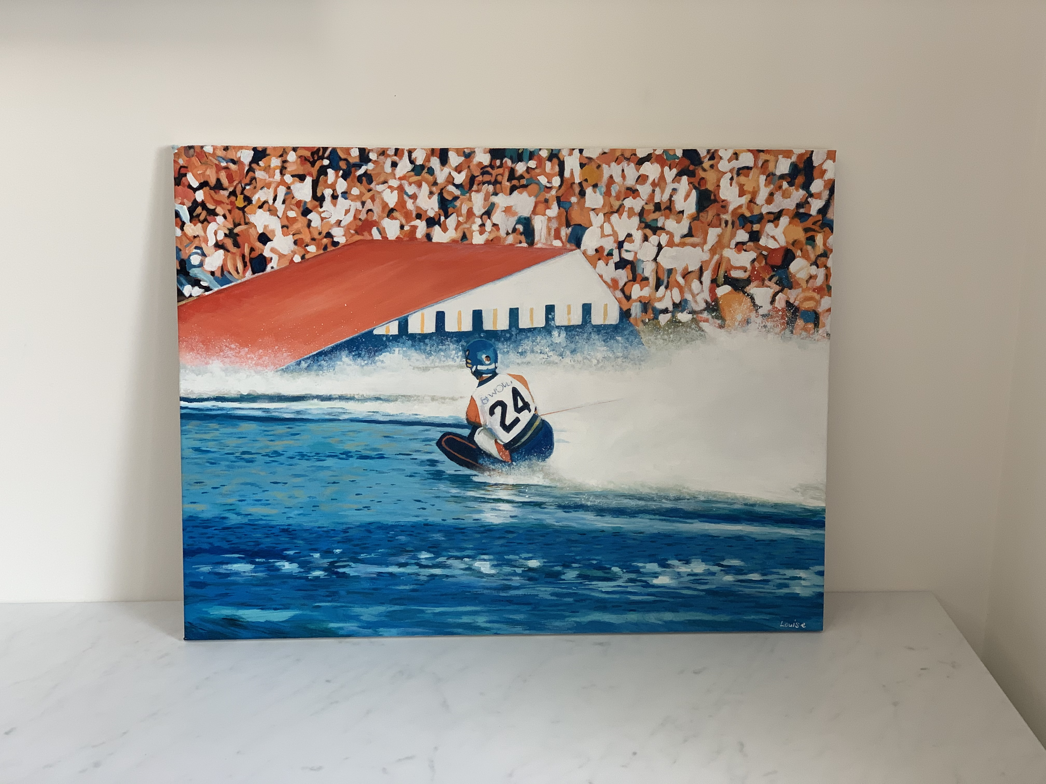

“200ft takes Overall”

Louise Cobbold, “200ft takes Overall”
Signed by artist lower right, acrylic on canvas.
Measurements: 45cm x 60cm
The Story:
Is this the most iconic water ski shot of all time?
Sammy Duvall headed into the ramp for the jump that took the title of Men’s Overall World Champion and Men’s Jump World Champion at the 1987 World Championships, Thorpe Park, United Kingdom.
Sammy Duvall had dominated the Men’s Overall for 6 years. The reigning World Champion was at his peak, taking only one jump in every two sets, but Mike Hazelwood remained as the reigning World Jump record holder.
In the Men’s Jump Final, the banks were filled with excited spectators. Mike Hazelwood went out and raised the bar to 194ft. Next up was Sammy Duvall, he went 195ft on his first jump to take Jump Gold and needing 200ft to win Overall, Duvall then flew 200ft to take the Overall title. The crowd went wild!

The Artist:
Having made the decision to pursue her dream of becoming an artist and illustrator, Louise Cobbold left her job as a teacher and began selling her work. Working with watercolour and acrylic, she produces a range of original pieces of art including people, pets, nature and landscapes.
However, Louise’s work really caught attention earlier this year when she showed her flare for sporting creations with a collection of 13 paintings of footballers, which raised over £12,000 for charity. She is also the appointed artist for the matchday programme at Premiership Football Club Wolverhampton Wanderers.
In their pursuit to raise money for the development of young talent and support of elite skiers, Friends of Tournament approached Louise with this idea taken from an original photograph taken by Steve Sopp. Included in the auction is the original acrylic on canvas and a print. Print one of ten has been transported to USA and signed by Sammy Duvall himself. ALL proceeds from the sale of these items will go to Friends of Tournament.

Auction Lots:

Lot 1) “200ft takes Overall”
Louise Cobbold, “200ft takes Overall”, signed by the artist lower right, original acrylic on canvas.
Measurements: 45cm x 60cm

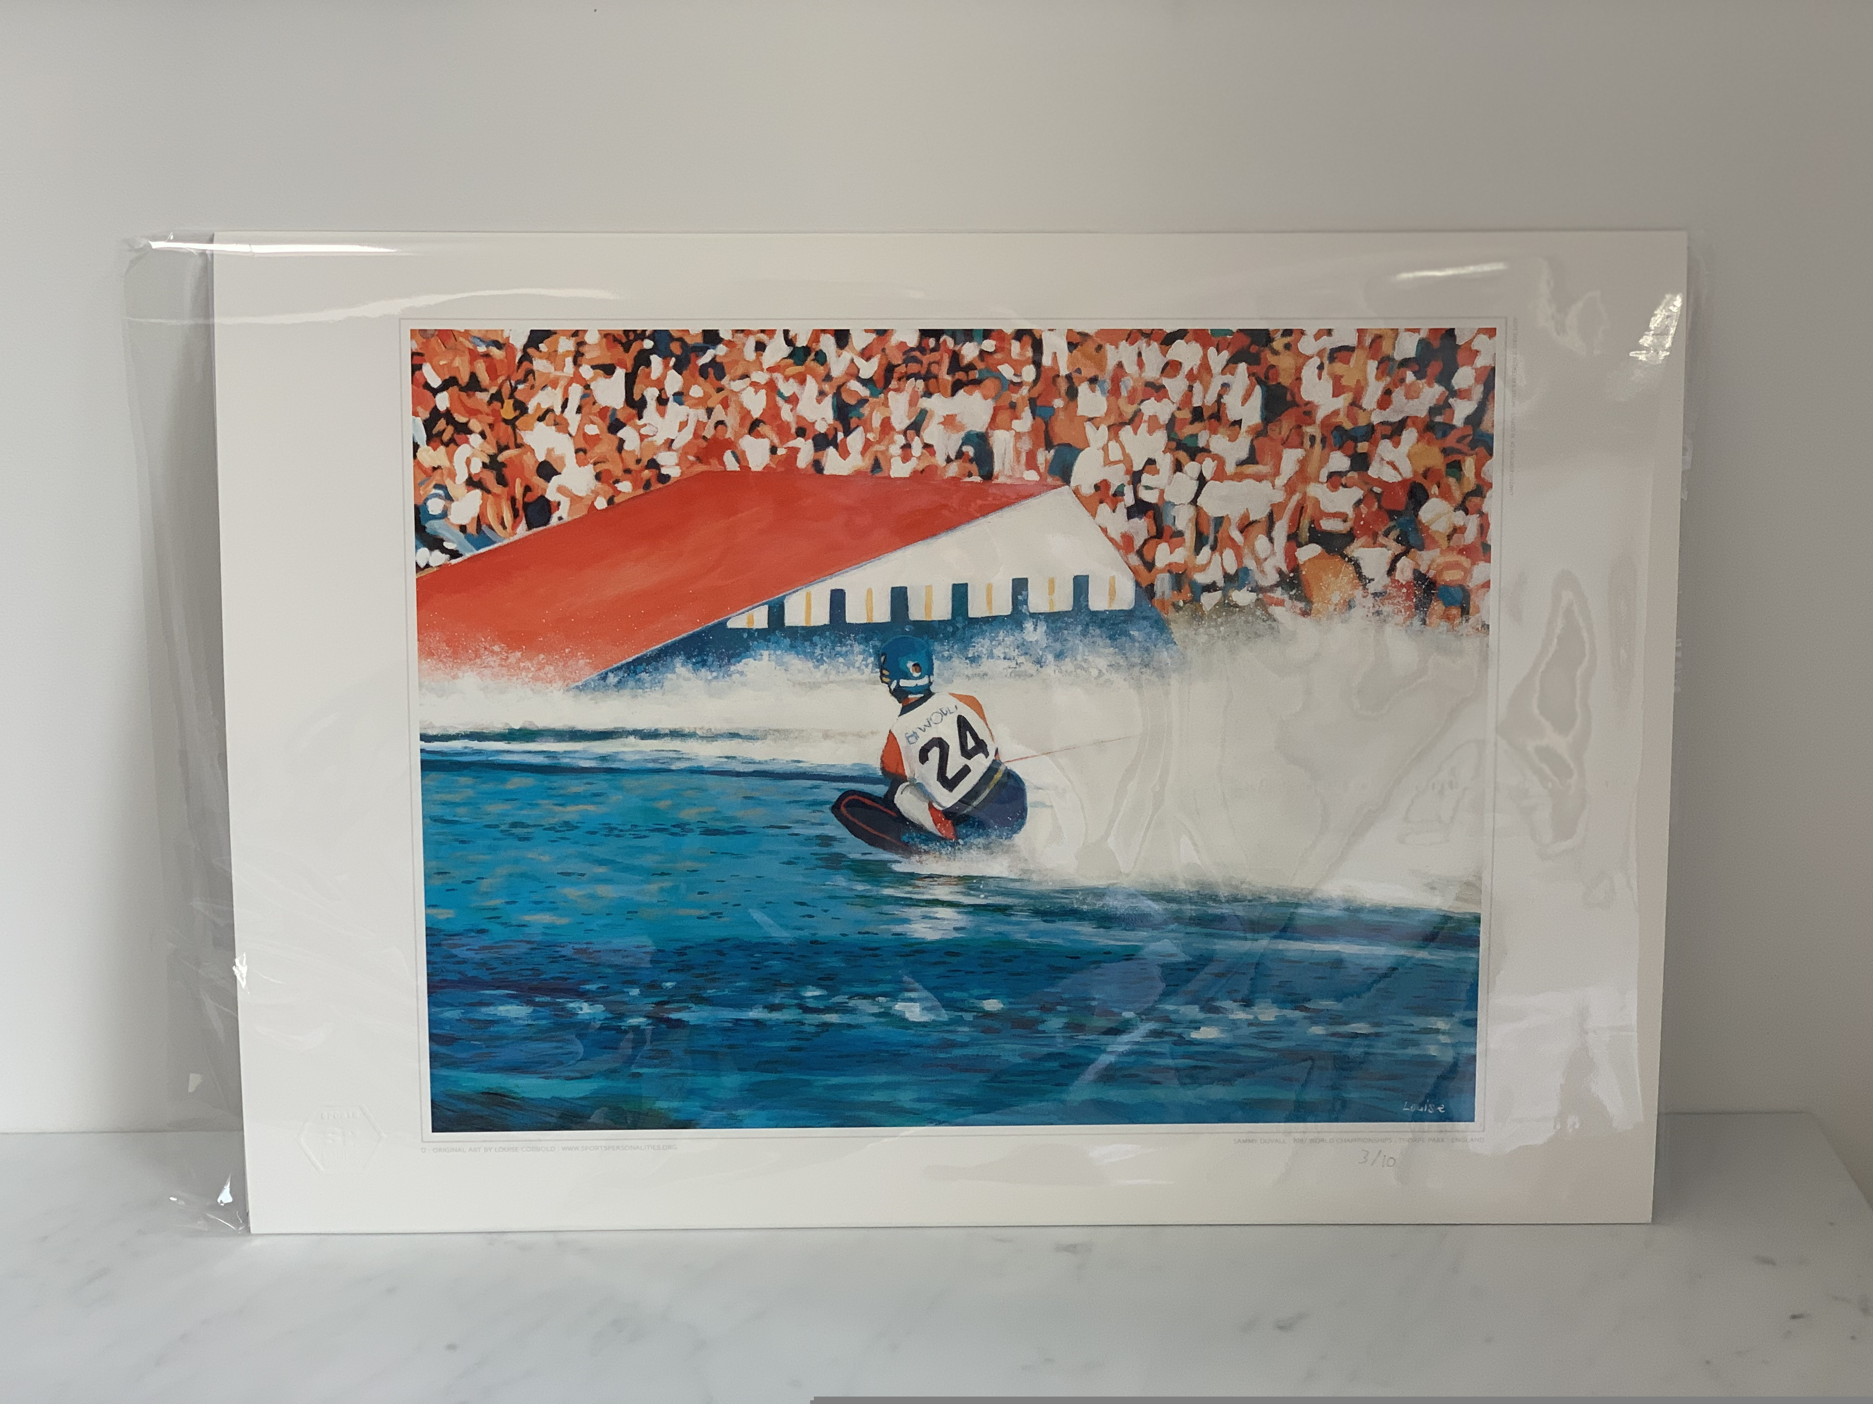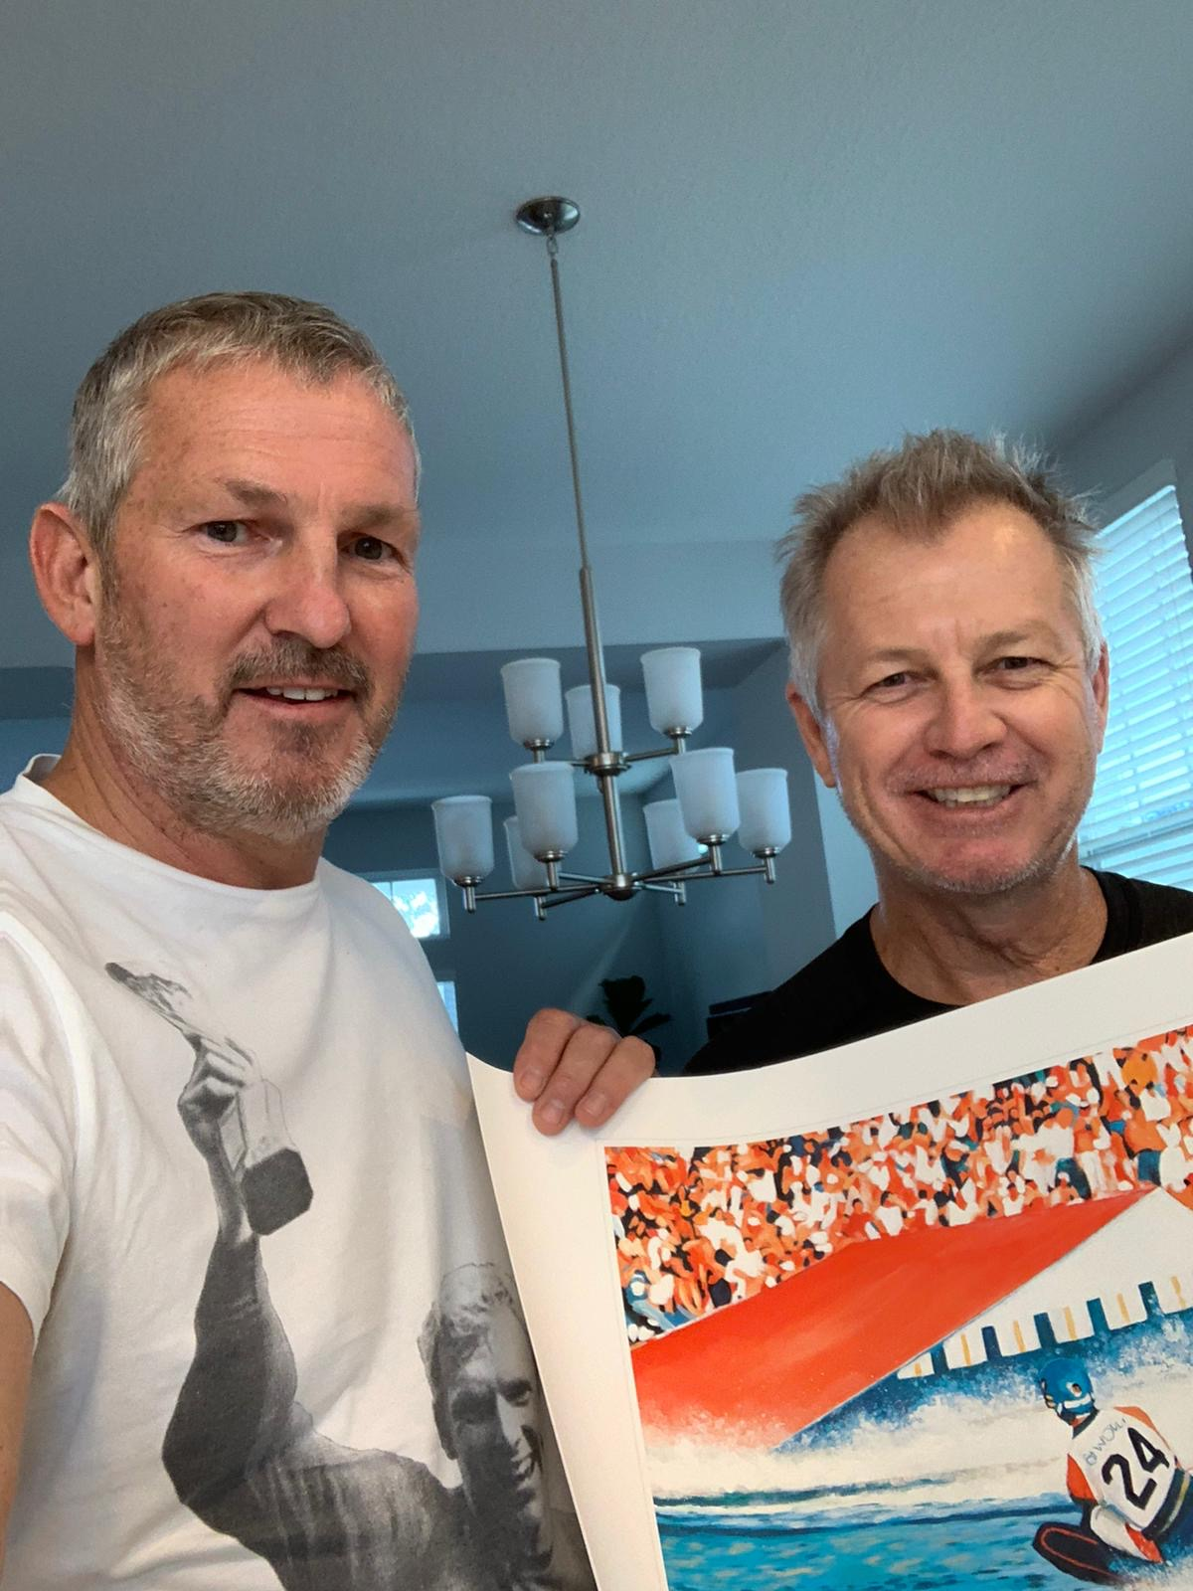

Lot 2) “200ft takes Overall” signed print
Louise Cobbold, “200ft takes Overall” print number one of ten, signed by Sammy Duvall.
Measurements: 42cm x 60cm

