Eleanor Benjamin

Eleanor now works full time as a Radiographer in London. She trains at OWSC in Oxford with Steve Glanfield at the weekends and midweek when her shift patterns allow it. Eleanor was in the Open GB Squad for 2019 and represented Great Britain in the 2019 World Championships in Malaysia, where Team GB placed 5th. She placed in the top 5 overall women in the 2019 European Waterski Championships and won 3 silvers and one bronze medal at this year’s 2019 National Championships. Team captain and team member of the consecutive four times National Champion’s at The University of Louisiana at Monroe waterski team.

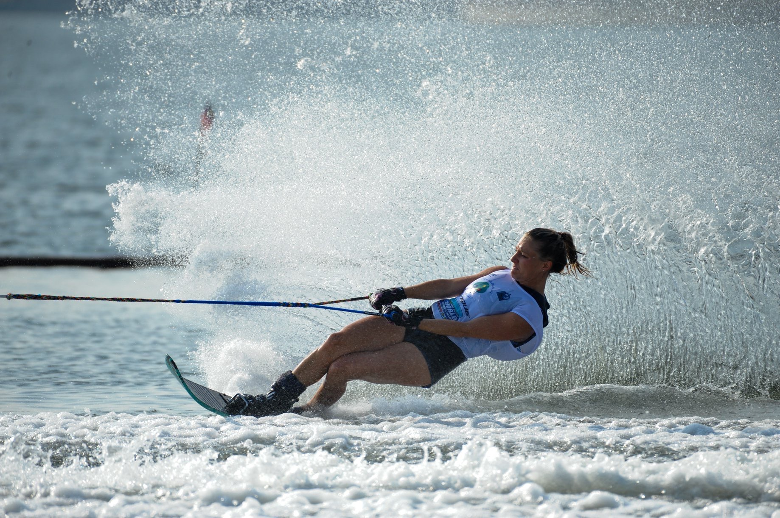
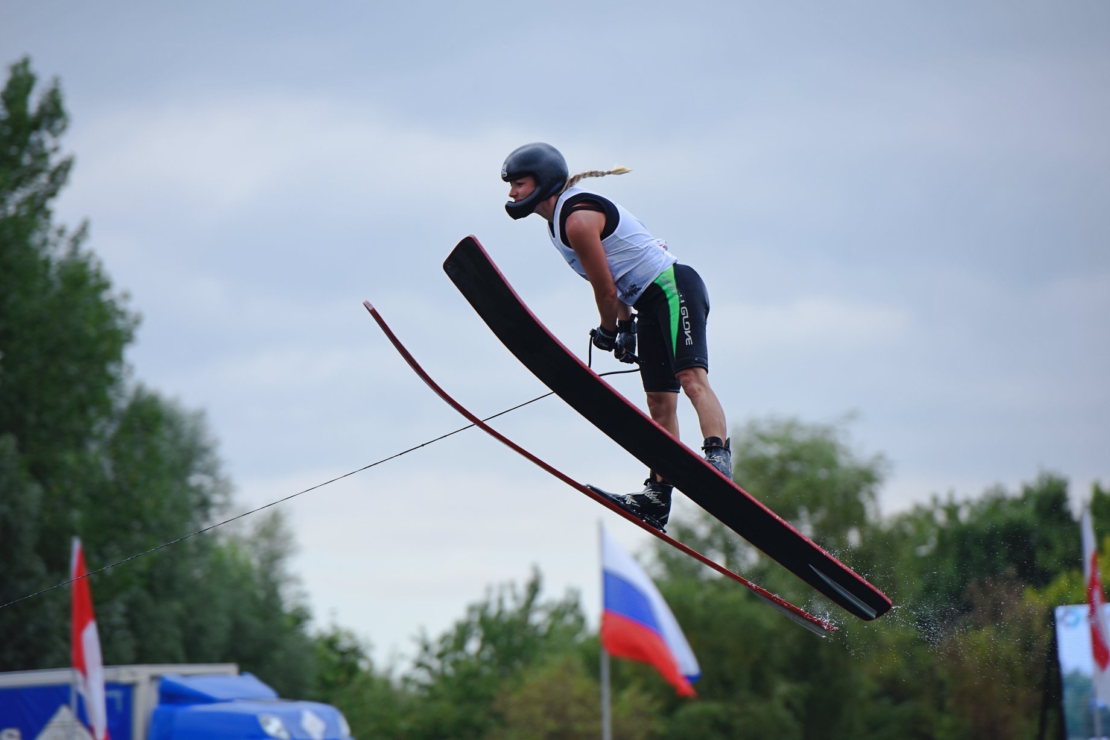

- How did your love of water skiing come about and how old were you when you started competing?

I first started waterskiing around aged 7. My Dad got my sister Jennifer and I into skiing, after he had tried it out on a local reservoir in North London. Dad was eventually taught how to crash properly rather than how to ski, so he started to research local waterski clubs with coaching, which led us to Liquid Leisure and Thorpe Park. This is where we both first learnt to ski. Mum and dad would go skiing at the weekend and we just loved the water, so we would be in a wetsuit all day and learned to ski when we fancied it. My first memory of water skiing is on Timm’s Lake at Thorpe Park on my handmade wooden slalom ski with Shawn Bronson and my parents.

I would ski most weekends in the summer as a child but it was always for fun, and I didn’t start competing until the age of 15. My main sport at the time was trampolining, where I represented Great Britain at both European and World level. However, I broke my ankle quite badly trampolining aged 14, which forced me to have quite a lot of time out. This led me towards competitive skiing - I was able to duct tape my ankle up and slalom instead. Being outside all summer, around skiers and at competitions was just so much fun. I only slalomed at this point and remember competing in my first National’s in 2005 at Thorpe Park. I saw all the other girls tricking and jumping which spurred me on to learn too. I learned to trick and jump aged 15/16, which felt quite late compared to everyone else, but it looked like so much fun to compete in all 3 events.

I made my first GB team aged 27, when I competed at the European Championships in Fischlham, Austria. It was always a goal of mine to make a GB team and ski at one of these events, no matter how old I was.

- Did water skiing lead to you studying abroad, or did you always intend to? Did it enable you to gain entry to university?

Both waterskiing and having a sibling at The University of Louisiana at Monroe (ULM) inspired me to study at ULM. I had heard about studying abroad and scholarships at American Universities, but I didn’t really know anyone that had done it at the time I was applying for University in England, and there was not much information available to me.

I completed my undergraduate studies in Sports and Exercise Science at Brunel University, West London. During my final year, my younger sister Jennifer went to America to study at ULM, and had received a scholarship for waterskiing. It was her experience that encouraged me to pursue this opportunity too. I would have found it very difficult being on my own all that time, but having my sister there made it much easier, and also fun.

I graduated from Brunel University in July 2011, and enrolled to start my Master’s degree in Sport Science at ULM in August 2011. It had taken around 6 months to complete the scholarship application process with endless paperwork to complete. The Masters programme takes 1.5 years, and at that point I still wasn’t certain about my future career, so I enrolled in the Radiologic Technology (Radiography) programme. I completed the extra credits required (plus some transferred from England) over the summer and started the Rad Tech programme in August 2014. It was a 2 year course with 20 hours of classes and 20 hours of hospital rotations each week. This included 2 autumn semesters, 2 spring semester and 2 summer terms (so anyone interested would have to stay for the whole summer in their final year). I graduated in May 2016 with a BSc in Radiography, and went on to work for one year in the USA under the OPT visa in Santa Rosa Beach, Florida at the Sacred Heart Hospital on the Emerald Coast. The OPT visa enables students to work in their specific degree field and gain experience for one year in the USA. I would highly recommend this, not only for the experience and amazing opportunity it is, but if you return to the UK for work it really helps when applying for your accreditation.

- How transferable are your qualifications if you wanted to work in the UK? Did you have to take any further exams?

The Radiologic Technology degree (BSc) that I gained at ULM was approved by The Health and Care Professions Council (the health regulator for health and care professionals in the UK). I went through the international route, which is a process that required lots of paperwork and it took around 6-8 months for them to fully convert my degree to British Standards. All British Radiography degrees go through the same process with the HCPC but it is a much shorter and quicker process, so you would definitely need to start applying at least 8 months before you move back to England to get all the paperwork completed in time. A lot of the paperwork has to be completed by the University, so it’s useful to do that whilst you are still there.

- What were the best and worst things about studying in America? What did you miss most about home? Would you recommend studying abroad to other young skiers?

I would certainly recommend studying in America to all the young skiers out there. It is an amazing experience and gives you the ability to get a degree and continue to waterski at the same time. At ULM your accommodation, gym, lake and university campus are a maximum 10 minute cycle from each other. Therefore, you can ski or go to the gym in between classes. Having the bayou on your doorstep is incredible and you can ski from pretty much sunrise to sun set. The university library overlooks the bayou where you ski, so you can watch the skiing from the 5th floor of the library. The American education system is brilliant for being able to pursue your education and your sports dream at the same time.

The best thing about studying in America are all the new experiences, the different places and ski lakes you’ll get to visit, and the life-long friends that you make at University and from within the waterski community.
Some of the most memorable experiences have to be Collegiate Nationals. It is an incredible experience, and brings a whole new meaning to waterskiing, so I would definitely recommend it.
The things you miss about home the most are the food, your friends and your family. But the semesters really do fly past and you are back home for the summer and winter breaks before you know it.

- Last year you achieved your goals of making the GB squad, attending the Worlds and Europeans, as well as a new trick PB. What are your plans for 2020?

My goals for this year are to continue to improve across all disciplines, and to make the Open Europeans Team. I PB’d in all three events in 2019, which I was extremely happy about, and would love to do the same in 2020. I try to be realistic with my goals, as I can’t ski as often as I used to now I am working full time, but it motivates me to work as hard as possible in the time I have. I am also excited that the British Nationals will be held at my home site OWSC, and that I am still able to compete in this sport and am able to represent Great Britain. The funding that Friends of Tournament provides when going away to compete at these events really does make such a big difference, and I don’t know if it would be possible without it, so I am very grateful for that over the past couple of years.

