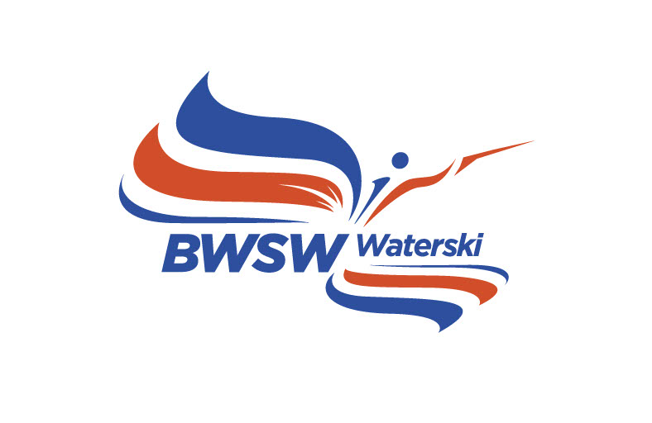

British Waterski – First Aid Report

Chief Judges Report of Injuries at Waterski Events

Attending Medical Personal

NAME | QUALIFICATION

Competition |  | Venue
Date |  | Chief Judge

This Report is for incidents involving injury to competitors and officials only. This need not be completed in the case of injury to spectators unless their injury arises because of an incident caused by skiing.

Incident Date: |  | Incident Time:

Injured Persons Name

Injured Persons Address

Was the Injured Person | SKIER/ OFFICAL/SPECTATOR

Which Event | SLALOM/ TRICKS/JUMP

Brief Description of Incident

Brief Description of injury

Was the Injured Person taken to Hospital | YES/NO
Transport Method | AMBULANCE/CAR/OTHER

Hospital Address and Telephone Number

Other Remarks

Submitted by:

Chief Judge Date

