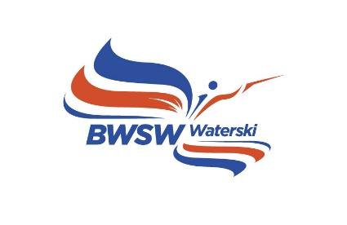

Chief Judges Report

Name of Competition:
Comp Reg No: |  |  | Date:
Venue:
Organiser Name and Address:
Level of Homologation (if any) {None or RL or RC}
Format of Competition – Events/Rounds
Number of Slalom Tows
Number of Trick Tows
Number of Jump Tows
BPMS Used?
Chief Judge
Scorer(s)
Homologator(s) (if any)

If not homologated:
Has the slalom and/or jump course been checked this season? {yes or no}
Are all courses straight? {yes or no}
Have all lines and handles been checked? {yes or no}
If applicable, is the Jump Open and the height(s) been checked? {yes or no}
If applicable, has the Jump Measurement System been Verified? {yes or no}

Judges:
1 |  | Qualification
2 |  | Qualification
3 |  | Qualification
4 |  | Qualification
5 |  | Qualification
6 |  | Qualification
7 |  | Qualification
8 |  | Qualification

Drivers:
1 |  | Qualification
2 |  | Qualification
3 |  | Qualification
4 |  | Qualification

Note: Please complete officials’ logbooks for those Judges and Drivers undergoing training.
For any other comments about the competition or officials, please add below.
Other comments:

First Aid Personnel on site:
1 |  | Qualification
2 |  | Qualification
3 |  | Qualification

Were there any incidents with injuries? {yes or no}
If yes, then please complete an Injury Report Form

An Injury Report Form can be downloaded on the following link :
http://www.tournamentwaterskiing.org.uk/resources/
This form should be emailed to toutech@bwsf.co.uk immediately after the competition, along with any confidential comments if any.

Submitted by: (Chief Judge)

Date:

