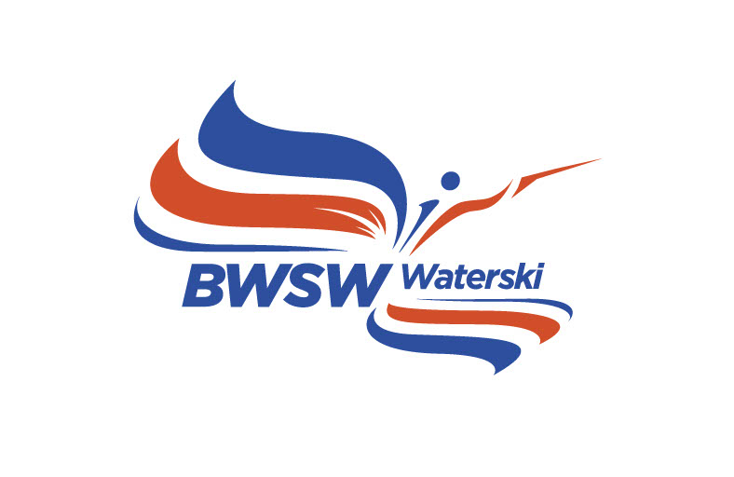
BRITISH WATER SKI & WAKEBOARD - WATERSKI COMMITTEE

Application For Ratification of a British Record
No person may claim a British record unless they are members of British Water Ski & Wakeboard and are in possession of a current Waterski Competition Licence for the year of the performance.

Name of Skier

Address

Date of Birth Age Category

DETAILS OF CLAIMED RECORD

Name of Competition

Place Date

PERFORMANCE:

Slalom Buoys Speed. Rope Length

Competition Start Speed Skier's Start Speed

Tricks Points

Supporting recording and Judges sheets to be attached if over 7000 points

Jump Distance Ramp Height Max. Speed allowed

Grade of Homologation of event concerned

Name of Chief Judge Homologator

===========================================================================
Enclose a complete set of the official results of the competition and send this form within 14 days to:-
Toutech, BWSW, Unit 3, The Forum, Chertsey, Surrey, KT16 9JX.

