Friends of Tournament

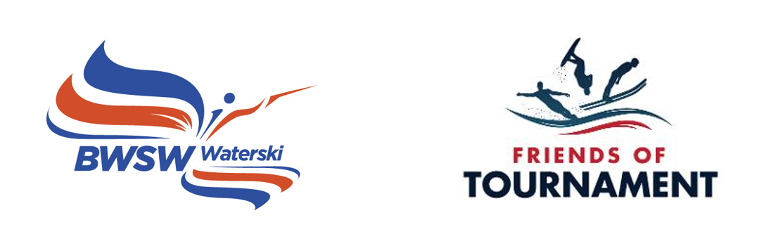
Monthly Newsletter

Issue No. 1 April 2022

Friends of Tournament - March 2022
- Gross amount raised to date - £217,812
- Prize Money – £58,639
- After 200 Club Prizes - £159,173
- Spend to Date - £91,616
- Skier Travel Grants - £60,256
- Development Days – £11,541
- Trick/Jump Skis - £6,372
- Squad Training - £10,512
- Handicap League Prizes - £935
- Paintings and Prints 2021 - £2,000
- Available Funds - £67,556
- FoT Account @ 15/04/22 - £75,498
- Spend 2021 (Final) - £36,015
- Carry over into 2022 - £57,100
- Budget 2022 - £63,945
- Projected carry over into 2023 - £49,665
- Projected Budget 2023 - £65,720
- Projected carry over into 2024 - £39,965
- March Changes: + 7 and – 2 tickets
- 162 balls in the bag this month with prizes of £1,316.25
1st - £526.50
2nd - £394.88
3rd - £263.25
4th - £131.63
- So far 218 prizes have gone to 100 different winners.

Monthly Newsletter
This is the first edition of what will become a monthly newsletter about Friends of Tournament. Please give us feedback. As long as it’s constructively critical we will take it on board.
The 200 Club Draw
The 63rd 200 Club March 2022 prize draw has taken place and the lucky winners are:
1st Andy Fearn – No. 102
2nd Jean-Paul – No. 145
3rd Ian Campbell – No. 70
4th Kevin Lochhead – No. 131

Congratulations to them and a big thank you to everyone who supports FoT through the 200 Club.
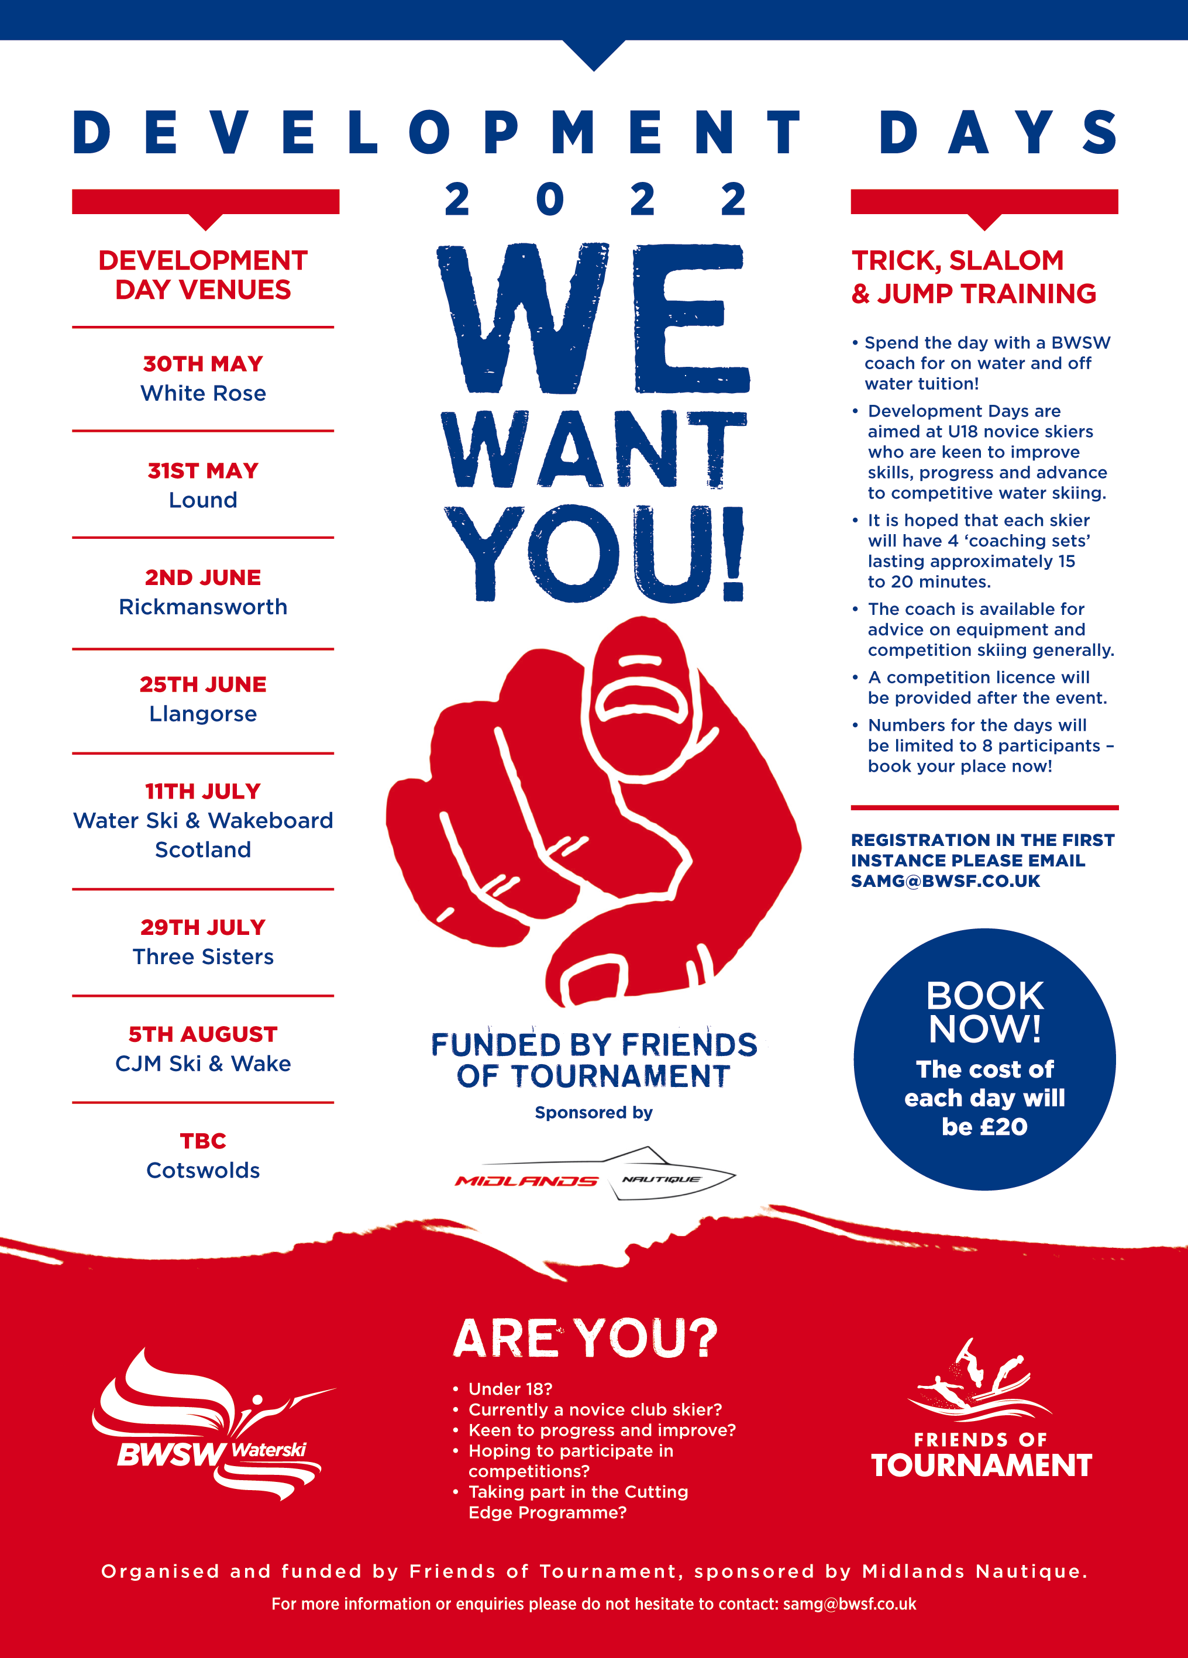
Development Days
The FoT Development Days programme for 2022 has now been finalised and published. This year the cost to each participant has been reduced from £30 to £20 and each day will host a maximum of 8 skiers. We expect them to be sold out quickly.
Squad Training
Two Squad Training camps at Gosfield and PTWC (Hazelwoods) for members of the U21, U17 and U14 squads have been organised and details have been sent out to the skiers invited to take part.
Coaching Vouchers
FoT paid a visit to Chris Mullins opening weekend for his new club, CJM Ski & Wake, located on Longside Lake near the village of Thorpe. We were pleased to give him 10 FoT Coaching Vouchers to encourage his young skiers. A Development Day has also been added to the calendar.

Friends of Tournament achievements to date
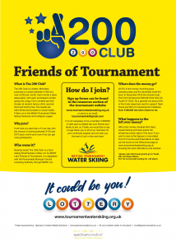
FoT, a sub-committee of the Waterski Committee, was established in 2017 with a remit to raise funds to support our Elite skiers who represent the UK at World and European Championships and to support various grassroots development initiatives. The main fund raising is generated through “The 200 Club”, the monthly lottery. 32.5% of the funds raised each month are paid out with four prizes. FoT money is held in a designated fund and has it’s own bank account within BWSW. Currently we have 162 balls in the bag each month but have an ambition to reach that magic 200 number. Current highlights can be seen in the column on page 1. A sign up form for the 200 Club can be downloaded via the following link so please encourage your friends, your ski club, and anyone else to join us.

http://www.tournamentwaterskiing.org.uk/wp-content/uploads/2021/11/200-Club-Sign-Up-Form-2022.docx
Friends of Tournament Budget 2022
We have an ambitious budget for 2022 which exceeds £63,000. We plan to increase the support grants to our Elite skiers for World and European Championships. On the Development side we have available loan equipment, (Slalom, trick and jump skis). 8 Development Days are scheduled and Coaching Vouchers will be awarded for various events such as the National Championships, and the Handicap League if we succeed in relaunching it this year.
The Jill Howard Legacy Fund
As most of you will be aware we were able to announce at the End of Season Ball last November that our friend Jill Howard who sadly died last year after battling cancer for some time had very generously left a large sum of money to Friends of Tournament. We should receive this bequest later this year and are thinking about initiatives that this fund can support that are out of the scope of our current fund raising. We will of course let you know as these plans come to fruition.
Thank you for reading and for supporting Friends of Tournament.
Mark, Gavin and Dusko
FoT Committee

