Friends of Tournament

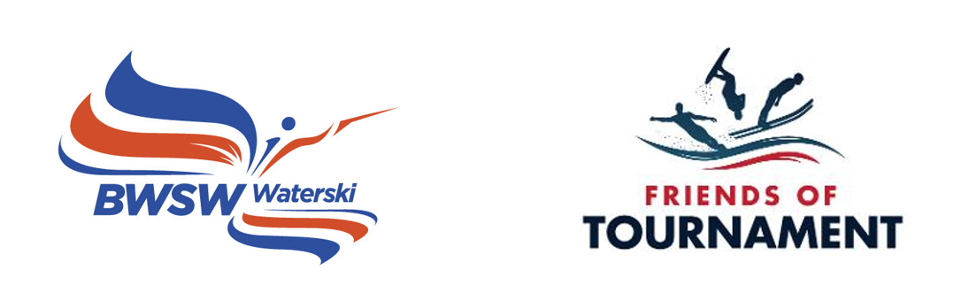
Monthly Newsletter

Issue No. 2 - May 2022

Friends of Tournament April 2022
- Gross amount raised to date - £221,962
- Prize Money – £59,988
- After Prizes – £161,974
- Spend to Date - £94,329
- Skier Travel Grants - £60,256
- Development Days – £14,066
- Trick/Jump Skis - £6,372
- Squad Training - £10,512
- Voucher Prizes - £1,122
- Paintings and Prints 2021 - £2,000
- Available Funds - £67,645
- FoT Bank Account @ 03/05/22 - £77,536
- Spend 2021 (Final) - £36,015
- Carry over into 2022 - £57,100
- Budget 2022 - £63,380
- Projected carry over into 2023 - £50,195
- Projected Budget 2023 - £65,720
- Projected carry over into 2024 - £40,951
- Changes this month: + 4 - 0
- 166 balls in the bag this month with prizes of £1,348.75
1st - £539.50
2nd - £404.63
3rd - £269.75
4th - £134.88
- So far 222 prizes have gone to 100 different winners.

The 200 Club Draw
The 64rd 200 Club April 2022 prize draw has taken place and the lucky winners are:
1st Jean-Paul No. 76
2nd Stuart Lillis No. 45
3rd Louise & Chris Roberts No. 49
4th Chris Ranner No. 137

You can view the draw by surfing to:
https://fb.watch/c-LzrBUcJB/

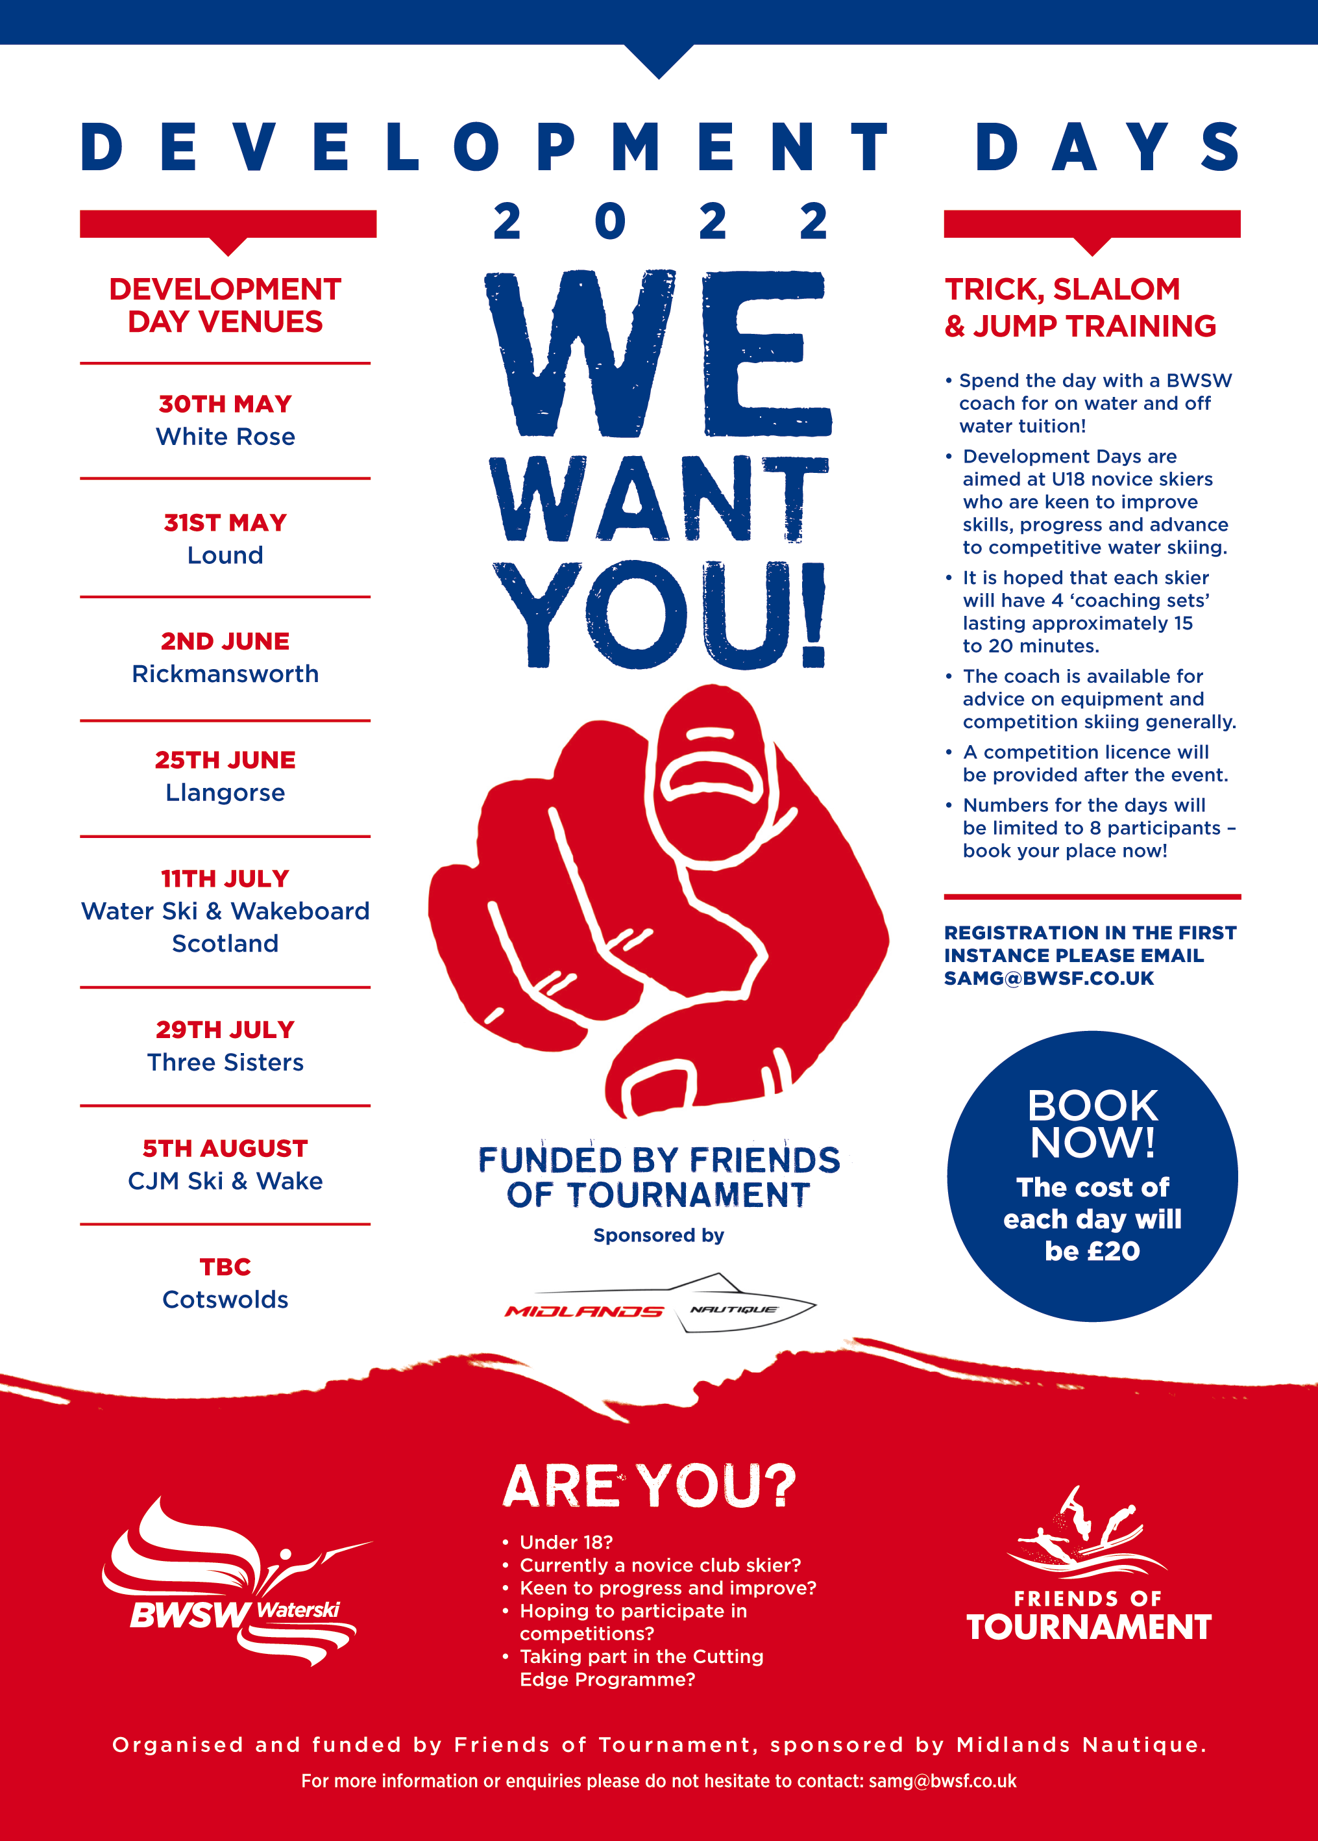
Congratulations to them and a big thank you to everyone who supports FoT through the 200 Club.
Development Days
As you can see from the poster 7/8 Development Days have been organised by FoT with support from Midlands Nautique. At £20 per head and a maximum of 8 skiers, these provide an excellent opportunity for young skiers to get a day of high level coaching and hopefully to encourage them to enter future competitions. All participants will receive a free British Competitors Licence for the 2022/2023 seasons. There are still vacancies on most of the days so don’t miss out.
Squad Training
FoT is supporting two Youth Squad Training days at Gosfield and Hazelwoods. This will enable our U21/U17 and U14 2022 Squad Skiers to spend time together in a training environment. Thank you to Vince and Charlotte for supporting this initiative.

Friends of Tournament achievements
FoT supported the recent Trick Training Camp held at the Waterski Academy in Whitworth. This was organised by Nick McGarry and featured four days of coaching by Nicholas Le Forestier, one of the most successful trick skiers in the sport’s history. Most of the participants were members of the Youth Squad or previous participants of FoT Development Days. Trick skiing is an area of weakness for us with the Women’s Trick Record of 6820 standing since 1984. We look forward to seeing the impact that Nick’s coaching has had on the skiers involved. FoT will continue to seek opportunities to improve the standard of Trick Skiing in the UK.

The 200 Club
The 200 Club is the main fund raising initiative of FoT and has gone from strength to strength since the first prize draw in January 2017 when there were 35 balls in the bag. In the April draw there were a record 166 balls in the bag. Of these, 129 people have one ball, 2 have four balls, 1 has three balls and 13 have 2 balls, a total of 145 people supporting the lottery. So far, some £59,000 has been paid out in prizes and 19 lucky winners have won over £1000. Of these 19, eleven have only one ball in the monthly draw. So if you or your Club would like to join The 200 Club a sign up form can be downloaded here:

http://www.tournamentwaterskiing.org.uk/wp-content/uploads/2021/11/200-Club-Sign-Up-Form-2022.docx
Friends of Tournament Budget 2022
The budgeted spend for 2022 is £63,380. This is always a little fluid as some plans don’t perhaps happen as intended or new initiatives are developed. However, this year’s budget is made up of the following:
- Skiers support grants for World and European Championships - £31,850
- Development Days - £10,000
- Squad Training - £4,250
- Youth Coaching Vouchers - £2,315
- National Championships Coaching Voucher Prizes - £3,150
- Winter Trick Training Project 2022/23 - £9,000

Thank you for reading and for supporting Friends of Tournament.
Mark, Gavin and Dusko
FoT Committee

