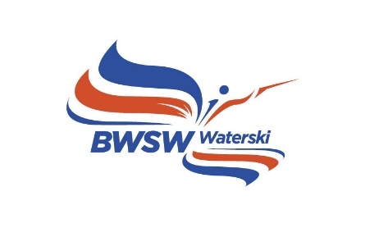

Bulletin 2

COMBINED BRITISH WATERSKI NATIONAL CHAMPIONSHIPS

We are proud to have been selected to host the Championships again this year. It’s going to be a mammoth task, but this announcement is a huge boost to our plans to raise the profile of waterskiing in the UK.

We look forward to welcoming back those that took part in the event last year and extend a warm welcome for those that are visiting us for the first time.

The Site

Oxford Wakeboard & Ski Club (OWSC) is a former gravel pit which had causeways added at a later date to give us two Slalom lakes and multiple options of where we can situate the ramp.
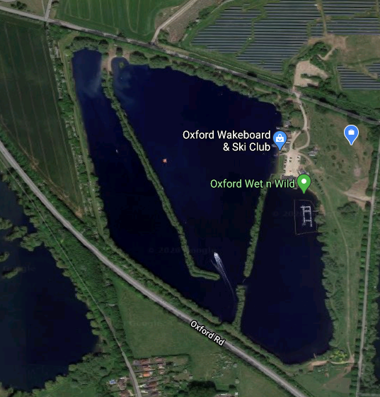

Lake 2

Lake 1

The general layout of the site is below, and we ask you to respect our wishes not to have cars anywhere else but the car park. With the inclusion of the adaptive categories again this year, there will be some reserved parking.

We are sign posted off the main road and outside the gate. The postcode does bring you straight to the gate and the full address is: -

Oxford Wakeboard & Ski Club
Queenford Lakes
Burcot Lane
Berinsfield
OXON
OX10 7PQ
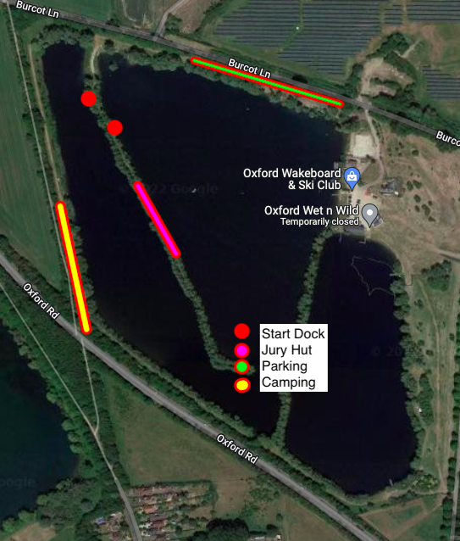

EMERGENCY ACCESS WILL BE THROUGH THE MAIN ENTRANCE AND FIRST AID POINT WILL BE LOCATED NEAR THE START JETTY

DATES

11th to 14th August 2022

ENTRY

Entries must be made online via the IWWF Event Management System (EMS). The Competitions are now open for entries. Entry Deadline is 28th July 2022.

QUALIFICATIONS

U10/U12 No qualifications required but if an U12 wants to jump they must have a registered score in a Competition at any time. This applies to other age categories and is a safety issue.

U14/U17/U21/Open No specific qualifications needed but must have a registered score at any time in the past for the events entered.

35+ No qualifications needed but must have a registered score at any time past for the events entered.

- Please note that both a British Competitors Licence and an IWWF Licence are required.
A one off IWWF Licence can be purchased on EMS

The Jury Panel
Chief Judge – Clair Hoile
Assistant CJ – David Stevenson
Homologator – Peter Davies
Scorer – Paul Airey
Assistant Scorer – Gill Heath
Judge – Gavin Kelly
Judge – Roy Collins
Judge – Barry Odell
Judge – Kevin Heath
Judge – Nick McGarry
Judge – Eleanor Benjamin
Judge – Amber Butterfield
Judge – Claire Ellis
Judge – Stuart Hills
Judge – Stuart Scott-Ely
Chief Driver – Vince Turp
Driver – Nathan McGarry
Driver – Tony Song
Driver – Will Oliver

Schedule
TBC

PLEASE NOTE THAT THERE WILL BE AN ADDITIONAL FLOODLIT SLALOM EVENT ON SATURDAY EVENING IN CONJUNCTION WITH THE PAELLA EVENING. WITH CASH PRIZES FOR THE TOP THREE PLACES IN BOTH MEN AND WOMEN THIS IS NOT TO BE MISSED
FULL DETAILS WILL BE PUBLISHED VERY SOON.

Numbers in Finals
16.4 Numbers in finals
In all National championships, except where other specific rules are quoted, where a final round is included, the number going through to the final of an event is based on the number of skiers on the start list at Midday the day before the Competition

No. of skiers starting in the Preliminary round within an age category & Number in Finals

1 - 5 All
6 - 10 First 5
11 - 12 First 6
13 - 15 First 8
16 - 19 First 10
20 or more First 12

To qualify for the Final Round a skier must ski and score more than zero in the Preliminary Round.
Note: see exceptions for Under 10, Under 12s under British Youth Championships and for 35+ under British 35+ Championships
Any skier qualifying for the finals and subsequently unable to take part will not be replaced by the next placed skier.

Please Note: Due to the high numbers of entries there will be no B Finals for 35+ Skiers.

Skiers Entering Age Category and Open Championships

Slalom – There will be only one preliminary round to determine the finalists for both Age Category and Open Events. The exception to this is for skiers who shorten at a different speed in their Age Category. They will ski in both Preliminary rounds.

Tricks and Jump - There will be only one preliminary round to determine the finalists for both Age Category and Open Events.

ENTRY FEES
Entry Fees remain unchanged at £50 per event and a £7.50 supplement if you enter your age cat and Open division
Please note:
With the uncertainty around rising gas prices a small surcharge may have to be added.

Payment to be made by BACS
Acc Name: OWSC Service LTD
S/C: 40-24-17
Acc Number: 92525844

PLEASE SEND CONFIRMATION TO bookings@oxfordwsc.com ONCE YOU HAVE PAID.

FRIENDS OF TOURNAMENT PRIZES
FoT will be giving coaching vouchers to all U17, U14 and U12 skiers who win Gold, Silver or Bronze medals in Slalom, Tricks and Jump. These can be used for a coaching set at any BWSW affiliated club to a value of £35 and will be valid until 31st December 2023. Gold medalists will get 3 vouchers, Silver, 2 and Bronze 1.

OFFICIAL TOWBOAT
All official practice and tournament events will be pulled behind the Ski Nautique, equipped with the latest version of Zero Off speed control on one of the two lake we offer.

OFFICIAL PRACTICE
This can be booked by calling 07974 369982 and will be on 10th August. Additional practice is available that week. Practice sets are 6 passes for slalom and tricks and 4 jumps. They will be charged at the prevailing members rate. Please be aware that we can’t guarantee which lake your age category will be on until closer to the time. On arrival, please report to reception to pay for any practice sets and your entry, if payment isn’t confirmed by reception before your sets, then you will not be taken and sets will be chargeable.

FOOD AND DRINK
There will be a BBQ available Thursday, Friday, Saturday and Sunday serving both breakfast and lunch time menus, from 8am till 4pm. Menu is as followed: cheese burgers, chicken gyros, veggie burgers, bacon baps, sausage baps and egg baps.

Along with a tea and coffee station.

On the Friday, The Pizza Post (a local pizza van) will be available on sight in the evening 4pm - 8/9pm) to order a freshly baked oven pizza from. There will be a menu consisting of 4 pizza options available soon, with gluten free and vegan available too. The pizza’s will be made fresh as requested form the customer and served to them then and there. All pizza’s will be pre-paid by Steve therefore people who wish to have pizza on the Friday night will just need to pay steve directly. This will save queuing time at the pizza van.

CAMPING
Plenty of space has been set aside for camping but please drop us a message to confirm so that we can guarantee the space set aside is big enough.

ENTERTAINMENT
As tradition, we have dinner and a live band performing on the Saturday night. This year we have chosen to serve up paella where there is a choice of chicken & chorizo, seafood and vegan. As usual, tickets will need to be pre-bought at a set price of £25pp.

COMMUNICATION
To be able to keep in touch with all the competitors we will start a WhatsApp Group so we can keep you up to date with any schedule changes.

