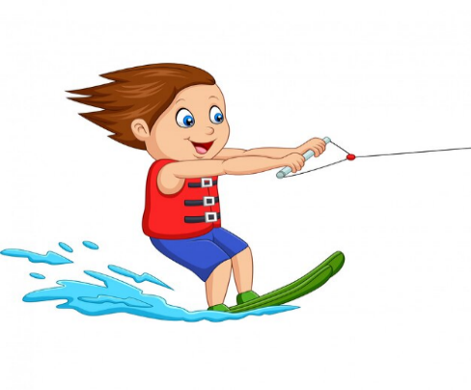
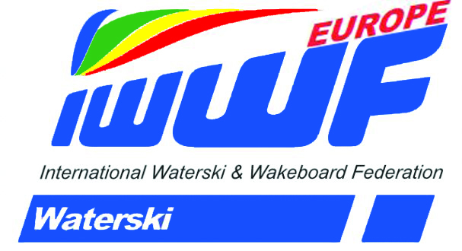

Newsletter of the E&A Waterski Council
Around the Buoys : No. 3 - October 2022
Thank You to all Our Officials
The 2022 season, at least in the Northern Hemisphere is drawing to a close and the WSC would like to thank all those Officials and Organisers who worked so hard to run the many competitions across our Confederation. Particular thanks to Austria, Greece, Italy and France where our E&A Championships were held as well as the first 35+ Worlds since 2018.
The Pamvotis Waterski Club in Ioannina hosted two titled events in three weeks, the 35+ followed by the Youth. Running one event is a challenge but running two is a huge commitment. In Baurech, More than 250 competitors took part in the World 35+ Championships requiring the use of two parts of the lake to run Tricks and Jump at the same time. Even so the event stretched to six days. Grateful thanks to the Miermont family and the French Federation for a successful event.
Calendar 2023
The full calendar can be accessed on EMS here: https://ems.iwwf.sport/
Here are the dates and locations for the World and E&A Titled Events. Currently the dates and venue for the European U21 Championships have not been finalised.
- 05/01 - 08/01 World U17 Championships: Chile
- 12/06 – 18/06 World U21 Championships, Mexico (Pending Approval)
- 09/08 – 13/08 E&A Youth Championships: Sesena, Spain
- 11/09 – 17/09 E&A 35+ Championships: Cazaux, France
- E&A Open Championships: San Gervasio, Italy (Dates to be confirmed)

Officials Seminar 2023
Next year it is planned to resume physical seminars after three years of Zoom based events. While these have been very successful in attracting a larger audience than would normally occur with a physical get together the Council feel strongly that there is added value and effectiveness when we are together. Hands on experience of the technology we use and more effective discussions on Trick judging being two particular areas. Of course, the social aspects of getting together are also of great value. So, the next seminar will take place in the UK at the Radisson Blu Hotel located at Stansted Airport. Many European countries have direct flights to Stansted so we hope that we will see a large number of Officials make the trip. The dates for your diary are 24th – 26th March 2023. A detailed Bulletin will be published towards the end of this year.
World Rules
The World Waterski Council issued version 2 of the 2022 Rulebook in May. There are two changes that require some explanation.
Rule 8.15 Revision - This update has been necessary because we are dealing with the introduction and adoption of new technology in the form of Boat Path Measurement Systems (BPMS), specifically SurePath, which is now providing detailed data on Boat Path performance which has simply not been available before.
It is clear from this data and the recent practical experience in competitions that a further modification to the rule was necessary. Data will continue to be monitored throughout this season and if any further changes are considered necessary these will be done as part of the annual Rules review process at the end of the year.
Rule 10.11 Revision – The skier shall tell the boat driver at which distance and at what speed to pass the ramp, and the boat shall follow a straight path through the jump course at the specified distance from the right-hand side of the ramp within the prescribed boat path tolerances. The boat path should have minimal deviation toward the jump ramp while the skier is cutting.
The use of SurePath has again provided significant data on boat path during jumping. The current rule stipulates a “straight path” through the course. The revised Rule recognises that the Driver needs to compensate for the skiers pull to the ramp thus avoiding a potentially unsafe scenario. Many Drivers do make the desired adjustment with minimal deviation from the “straight path” but the adjustment to the Rule will allow a better understanding of what is required. It is not intended that the Driver will “help” the skier with the landing.
Safety at Events
Safety in our activities is paramount both from the point of view of avoiding accidents and dealing with them in the best possible way should they happen.
The IWWF has recently published a revised and updated Safety Manual. This is still a work in progress and covers all Disciplines with links to Discipline specific Safety considerations. You can access this new guidance here:
https://iwwf.sport/wp-content/uploads/2022/08/IWWF-Safety-Manual_rev00_20220815_final.pdf
This document can also be found on iwwf.sport under the “Resources” section.
Judges Tower

Boat Path Monitoring – Rule 8.15
A particular focus of the IWWF in recent years has been about improving boat path monitoring to ensure adherence to the rules consistently around the world. This has led to the development of BPMS (Boat Path Monitoring Systems) such as SurePath and Splash Drive. While still evolving the use of such systems is now mandatory for Ranking List and higher homologated events. This new technology obviously takes some time for Judges and Drivers to understand it and to learn how to use it. Rule 8.15 deals with the application and use of these systems but can be difficult to understand. So, to help a one-page guide to the decision-making process for Judges and Drivers has been developed which can be downloaded here:
http://www.tournamentwaterskiing.org.uk/wp-content/uploads/2022/08/BOAT-PATH-MONITORING.xlsx
One point of clarification
Some have interpreted the rule to mean that use of a BPMS for Ranking List events is not mandatory until you get skiers into 11.25m. Recording of passes is necessary at 11.25m or less but the system can be used for all passes as indicated in Rule 8.15 Path Review – BPMS / End Course Video. If a BPMS system cannot be used throughout the competition due to technical issues, monitoring can temporarily revert to End Course Video until the issue is fixed. This must be noted in the Homologation Dossier. The use of End Course Video is still necessary to prevent misreading or recording error on the Boat Path deviation.
Scorers Corner

At the recent Officials Seminar, the problem of attracting new people to train as Scorers was discussed. It was felt that the challenge of learning to score the trick event was perhaps putting possible candidates off. The assumption has been that a two event Scorer (slalom and jump) was not allowed but in fact it is an option already identified in the World Rulebook, as a S2* (2 event Scorer). For National Scorers, S3* (2 event) are also allowed but this was not clear in the Additional Rules. This has now been clarified and has been reflected in an Additional Rules update published in May. Hopefully this option will make it easier to attract new Scorers.
Drivers Pulse

This year has seen the increasing use of BPMS. The aim of these systems is to help to continually improve driving standards and they are now mandatory for RL and RC events. One of these systems, SurePath, has the advantage of a small tablet or phone in the boat that gives the Driver information about his boat path that he can review at the end of each pass. Using this data, he can make the small adjustments necessary to minimise the deviations from the centre line of the boat lane and to avoid the problem of cumulative deviation.
Homologation and Technology Hub

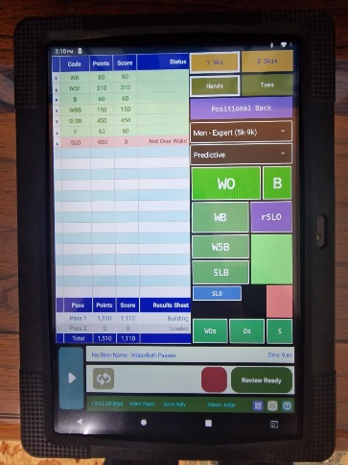
The new Eyetrick Trick judging technology has continued to evolve over the last few months and has been trialled successfully at a couple of events. A totally new way of judging that gives the possibility of immediate scores and the trick runs to be seen on screen as the skier takes his turn. It will of course take time to be introduced for use in events as the primary way of judging and will require changes to the current rules for Trick Judging. Initial analysis shows that scores using this system are largely similar to traditional judging and so either approach can be used.
Get in Touch

Please get in touch with us if you have any questions, observations or suggestions about this newsletter or any other matter concerned with the Waterski Council activities. Email Amanda at secretary@waterskieurope.com with anything on your mind.
and don’t forget to visit the Facebook page and website for information and news.
https://www.facebook.com/iwwfeatc
http://www.waterskieurope.com/

