E&A Waterski & Disabled Waterski
28th Annual Officials Seminar 2023
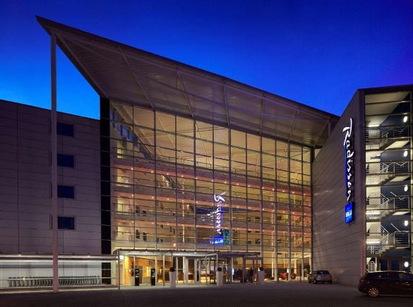
Bulletin 1
London Stansted Airport, Waltham Close, Stansted CM24 1PP
24th to 26th March 2023
Contacts:
Disabled Council Carmen Ferrer Bosch carmen.ferrerbosch@gmail.com
Waterski Council Hannu Rintanen htrwski@waterskieurope.com
British Waterski Gavin Kelly gavin.kelly@waterskieurope.com

E&A Waterski & Disabled Officials Seminar
Venue – Radisson Blu, London Stansted Airport, Waltham Close, Stansted CM24 1PP.
Dates 24th – 26th March 2023
Organised by
The Disabled & Waterski Councils of the IWWF Europe Confederation
The British Waterski and Wakeboard Federation

Dear Friends,
We are pleased to invite you to the 28th annual IWWF European Confederation Waterski and Disabled Officials Seminar to be held on the Radisson Blu, London Stansted Airport, Stanstead, UK.
This is the second seminar to be held in the UK, the first being 20+ years ago in 2000.
We would like to remind you that only those Officials who have attended an Official’s seminar within a three-year period will be considered for Titled Events and other major competitions. But of course, you are welcome to attend every year as there is always something new to learn and discuss.
This is the first physical seminar since the disruption caused by Covid and the WSC believe that it is important for us to meet together in the interests of the development of our sport and our Officials. So please make every effort to attend this 28th Seminar and make it as successful as all the others.
Candido Moz Dany De Bakker
Waterski Council President Disabled Council President

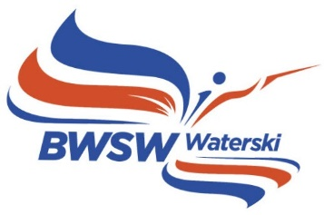
E&A Waterski & Disabled Official’s Seminar
Provisional Schedule
Friday 24th March: 14.00 – 18.30 Plenary Session (All together)
Friday 24th March: 19.30 – 23.00 Seminar Dinner in Hotel
Saturday 25th March: 09.00-18.00 Plenary Session (All) and Breakout Groups
Saturday 25th March: 19.30 – 23.00 Seminar Dinner @ Home & Eat
Sunday 26th March: 0900 – 12.30 Final Plenary Session (All together)
A detailed schedule will be included in Bulletin 2

Registration and Payment

It will be a pleasure to welcome you all to our meeting venue situated literally right next door to London Stansted Airport (STN), 40 miles from the centre of London, GBR – one of the World’s greatest cities! Our choice of venue means that you can very conveniently exit out of the airport, turn left and after a short 2-minute walk or roll down the ramp, find yourself inside the lobby of the host hotel reception area. No cab required!

Registration is a three-part process:
- Register your details and intention to attend on the form available on the Waterski Council website.
- Book your accommodation options through Radisson Blu London Stanstead Airport hotel website.
- Book your seminar options through the BWSW website and booking system as outlined below.

Seminar registration must be made through the Waterski Council website www.waterskieurope.com. Registration will be open 2nd January 2023 and will be closed 5th March 2023.
Accommodation: You are entirely responsible for arranging your own hotel reservation. All Seminar participants should stay at the host hotel where special rates have been negotiated on your behalf. Central London is a 45-mnute train ride away with a direct connection to London Liverpool Street Station. If you and/or your partner fancies a weekend in one of the world’s tip-top cities, then London awaits your arrival. Some of the world’s most iconic sights, sounds, shows and experiences are all available for your pleasure!
The Seminar is being held on SAS Radisson Blu hotel. Hotel reservations, breakfast and lunch and all related payments must be made through the hotel website Radisson Blu London Stansted Airport Hotel . Hotel reservations cannot be guaranteed after 23rd February 2023.
Booking your hotel room is super-easy via the dedicated online reservation system here.
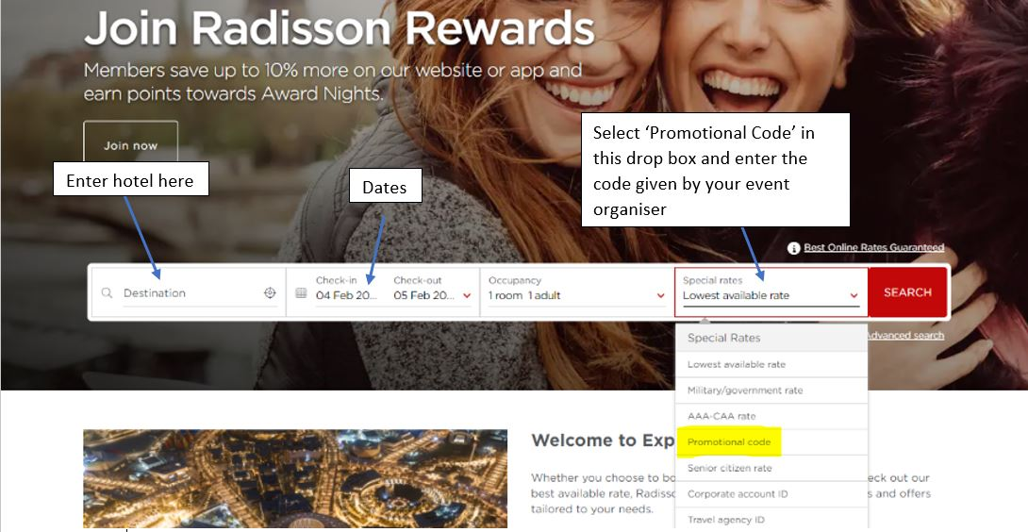
Please ensure you enter the special “Promotional code” WATERSKI assigned to our meetings in the “Selected Rates” drop down menu.
The deadline for reservations is: FRIDAY 23th FEBRUARY 2023
after which the specially negotiated room rates cannot be guaranteed!
Room Package: Included in the hotel reservation package is the following….
Special room rate: £119.00 single occupancy room includes full buffet breakfast
£129.00 double occupancy room includes 2 x full buffet breakfast, and….
Meeting Package: A Seminar Fee of £45 includes lunch on Saturday and meeting refreshments on Friday PM, Saturday AM/PM and Sunday AM. and is payable direct to British Waterski & Wakeboard via the registration process outlined below,
The Special Dinner with Entertainment on Saturday night is NOT included in the Room/Meeting Package above. The cost for dinner and entertainment is £40.00 per person & payable direct to British Waterski & Wakeboard (BWSW) via their web site.
You must and can only register, book and pay for your dinner reservation(s) here and note that the short and simple registration process is required as BWSW will be taking an online payment from you.
This process must be completed before 28th February 2023.
You will need to have a BWSW online account to book on to the event however, you do not need to be a current active member of BWSW. If you do not have an online account already, you can simply register now at https://www.bwsw.org.uk/membersarea/login/register_user.asp and continue to book on to the E&A Seminar event.
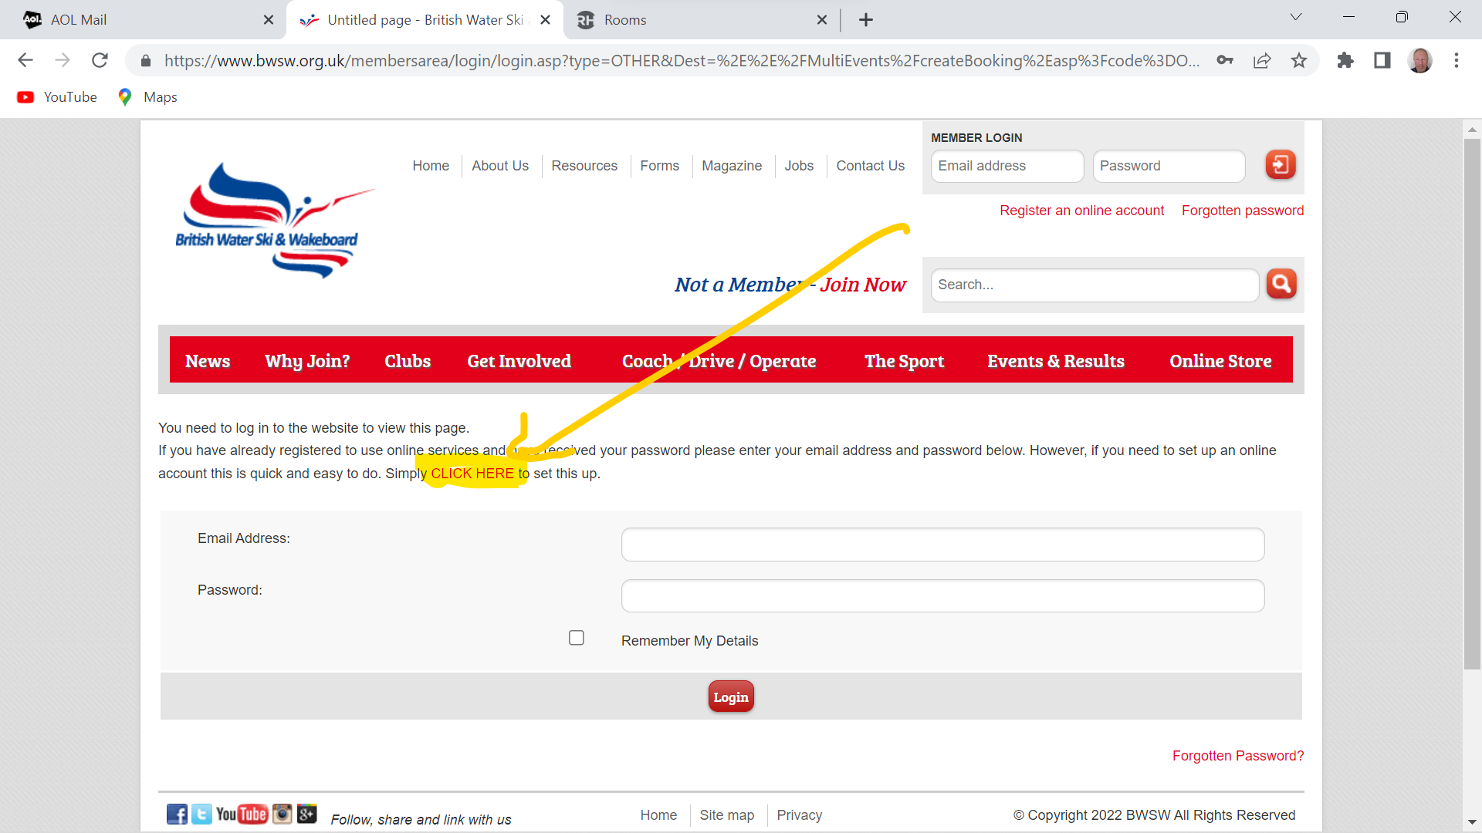
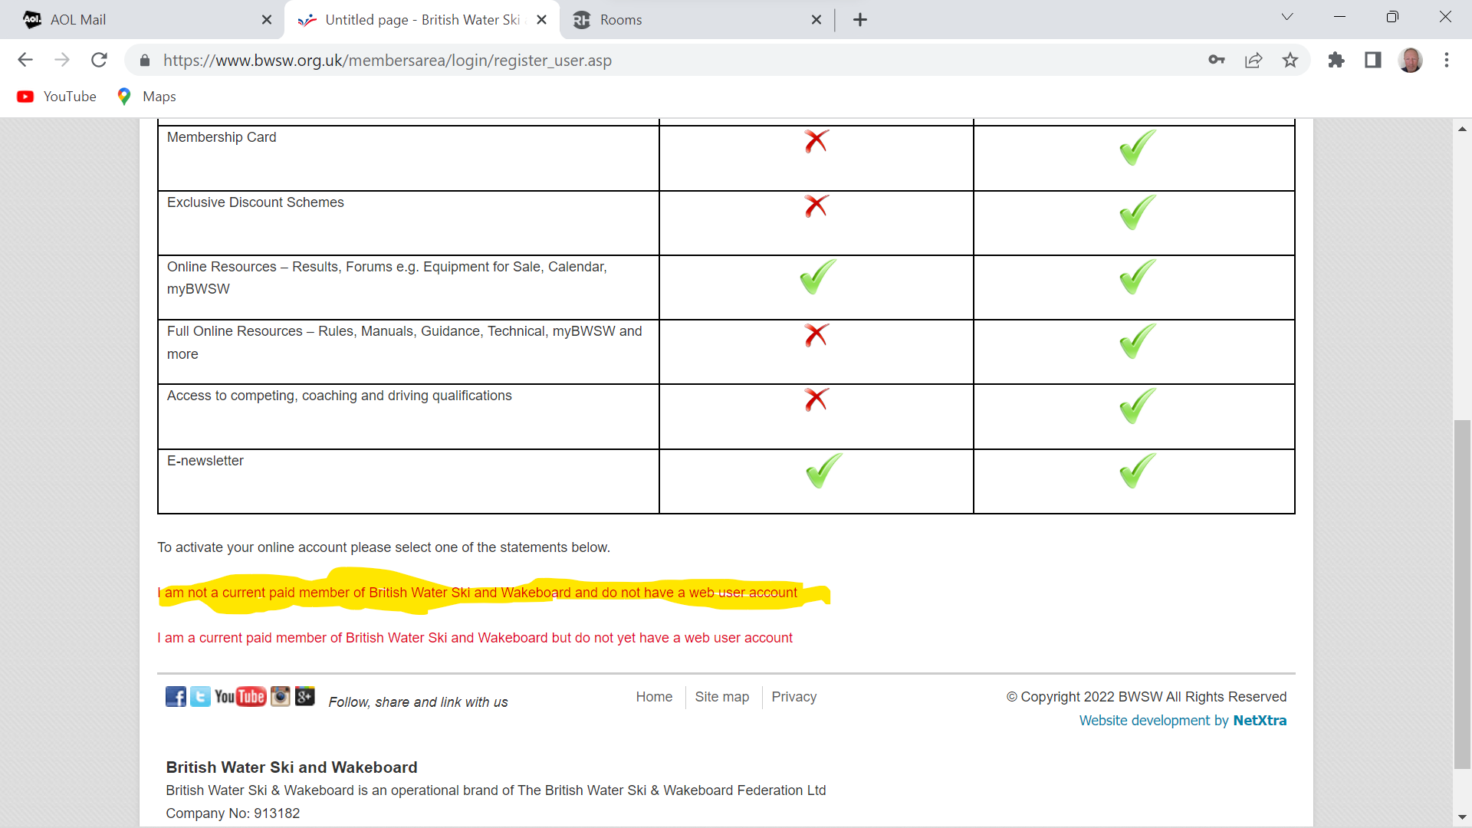
Normal rules apply of course for any and all other costs - you are responsible for them: e.g. room minibar, hotel bar, drinks in the restaurant, drinks at the dinner venue etc. etc. any other taxis, transportation etc. The hotel reception will ask for your credit card details on arrival to cover all incidental expenses and charges incurred in the hotel. All major credit and bank cards are accepted by all other venues and services.

Contact Information

If you have any problems with the registration process please contact Kylie at BWSW and Gavin by email:
Kylie Cooper
Email: kylie@bwsf.co.uk
Telephone: +44 (0)7799 81210/+44 (0)1932 579934
Gavin Kelly
Email: gavin.kelly@waterskieurope.com
Telephone: +44 (0)7876542711

Travel Information and Joining Instructions

Arriving at Radisson Blu Stanstead
Travel information: how to get to the Raddison Blu Stansted Airport…

The best way of course is to fly in to London Stansted Airport (STN) - served by most of the budget airlines and a few of the national carriers. You can also fly into any one of the 4 other London airports: London Heathrow (LHR), London City (LCY), London Gatwick (LGW) or London Luton (LTN).
You can still get to Stansted fairly easily from any of them, but you will need to allow at least 2 hours additional travelling time to and from the hotel each way.
If you do arrive/depart via one of the alternative London airports then be prepared for travel times being severely extended due to traffic and other surface transport services possibly being restricted, especially on Sundays.
Sundays are railway engineering/maintenance days in the UK when particular attention should be paid to the service interruptions on the trains if you need to use them. There are always alternative routes/modes of transport (busses/coaches) available, but they will add extra time to your journey so plan carefully. Ping me an email for the best routes to Stansted from any other London airports. Our brand-new Elizabeth Line is now open and really streamlines travel from to/from London Heathrow.

Check this link for coach/bus services and this link for trains to and from Stansted.

Travelling by train: If you use the EuroStar then it’s very easy to get to Stansted from London St. Pancras International by taking the London Underground (Tube) direct from London King’s Cross Station, which is across the road from St. Pancras International (just a 5-minute walk).
Take either the Circle (yellow), Metropolitan (purple) or Hammersmith & City (pink) Line eastbound straight through to London Liverpool Street; then take the ‘Stansted Express’ or Great Anglia overground train service from there.
Estimated total traveling time is approx. 1 hour and trains run frequently throughout the day and most of the night. All train services overground and underground in London are cashless so you must use your bank or credit card to purchase tickets. You can pre-book if you wish but there is no need – just pay and go - there and then.
It’s really simple and very easy - just make sure you choose the right ticket(s). Ticket machines work in pretty much any language – even English J ! You don’t need tickets if you travel on the underground system only - just touch in and touch out again with your bank/credit card and the system calculates the cheapest ticket for you.
Travelling by car: If you choose to drive, entering the UK via ferry to Dover, take the A2/M2 westbound from Dover and join the M25 following directions north via the Dartford (Toll Payable) Crossing. Continue north following the M25 to junction 27 and head north on the M11. Continue north and take junction 8 Stansted Airport/A120 and follow the airport signs for the Short Stay Car Park and then the Raddison Blu Hotel. Do not enter the Short Stay Car Park!
If you enter the UK with your car via Le Shuttle from France you need the A20/M20/M25 northbound towards the Dartford (Toll Payable) Crossing and then continue as above.
If you choose to drive entering the UK via ferry from Holland (via Harwich), take the A120 westbound from Harwich and join the A12 heading east towards Colchester. A mile past Colchester, at exit 25 Marks Tey, look for signs for the A120 towards Stansted Airport. Join the A120 by turning right from the A12 using the big roundabout. Head towards Stansted and then follow the airport signs to the Short Stay Car Park and then the Raddison Blu Hotel. Do not enter the Short Stay Car Park!
IMPORTANT – PLEASE READ IF YOU COME BY CAR. There is NO FREE CAR PARKING at the hotel whatsoever. You must register your vehicle registration details with the Concierge when you check in and they will charge your room account with your daily car parking charges which are approx. £18 per day!!! Not cheap and we are very sorry about this but there is nothing we can do about it. The hotel staff even must pay! You have been warned. It is possible to park in the airport car park and then take the free shuttle bus to/from the terminal building next door the hotel. It might be a little bit cheaper so good luck with that but please remember – you have been warned!

How to get to the Radisson Blu Hotel London Stansted Airport
Waltham Close, London Stansted Airport, London CM241PP, United Kingdom
The Radisson Blu is only 350 meters from Stansted Airport's main terminal, and within easy walking distance of the bus and train station.
The Stansted Airport rail station is located directly below the terminal building.
From Stansted Express Terminal On foot:
When leaving the Stansted Express terminal arrivals area, you'll only have a 350-meter walk to the hotel.
Train Tickets from Stansted
Tickets can be purchased there or in advance. The railway provides access to central and east London, eastern England, and the Midlands. Be sure to check beforehand with the train provider, as times and fares are subject to change.
Your best option for travel to London is the Stansted Express, which runs between the airport and London Liverpool Street. Trains depart every 15 minutes and stop at Bishop's Stortford, Harlow Town, and Tottenham Hale. London Underground stops are located at Tottenham Hale (Victoria Line) and Liverpool Street (Circle, Metropolitan and Hammersmith & City lines). For information on pricing, stop by our concierge desk.
Long-distance trains offer transport from the airport to Cambridgeshire and the Midlands with connections available to the North and Scotland. Trains run to Audley End, Cambridge, Ely, Peterborough, Leicester, and Birmingham. Monday through Saturday, the trains run every hour, but on Sunday, times may vary. For a cheaper fare, simply book in advance. Change at Peterborough to travel to Leeds, York, Newcastle and Scotland, and change at Leicester to travel to Derby and Sheffield.
Stansted Airport offers daily service to more than 130 destinations via 41 airlines.
Parking
Car parking is subject to availability at the hotel and is charged at GBP 18 per night for Seminar Delegates. For every additional night when a guest is not staying but parking their car, there is a charge of GBP 33 per night. All cars entering the hotel must be registered at reception. Failure to enter car registration details into the ANPR system will result in penalty charges by Parking Eye Ltd, who manages the hotel car park.
Seminar Registration at Hotel
Registration will take place in the foyer of the hotel on Thursday 23rd and Friday 24th March 2023

www.venue.royalholloway.ac.uk
sales-office@royalholloway.ac.uk
01784 443045

