Friends of Tournament

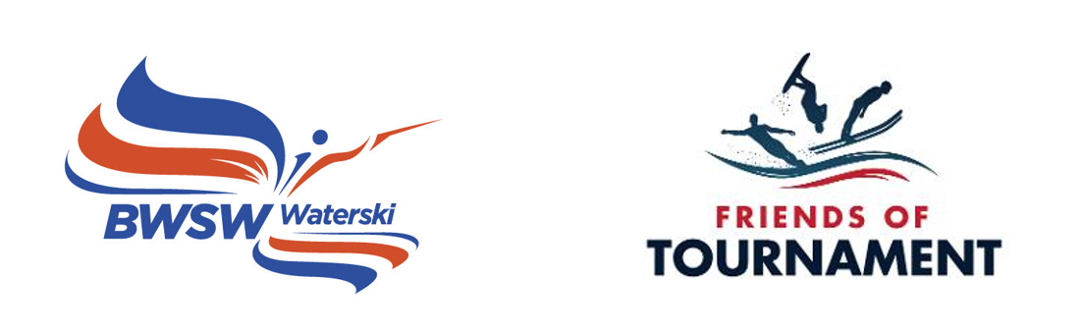
Monthly Newsletter

Issue No. 15 - June 2023

£301,000+ Raised TO DATE
Friends of Tournament May 2023
- Gross amount raised to date – £301,179
- Prize Money – £80,439
- After Prizes – £220,740
- Spend to Date - £151,454
- Skier Participation Grants - £87,856
- Development Days – £18,471
- Training Camps - £10,345
- Backyard Events - £1,175
- Trick/Jump Skis - £8,053
- Squad Training - £14,807
- Coaching Vouchers & JC Award - £3,726
- Paintings and Prints 2021 - £2,425
- Promotional Merchandise - £4,595
- Available Funds – £69,287
- FoT Bank Account @ 31/05/23 - £80,918
- Jill Howard Legacy Fund - £140,000
- Spend 2021 (Final) - £36,015
- Carry over into 2022 - £57,100
Final Spend 2022 - £50,543
Carry over into 2023 - £60,423
- Projected Spend 2023 - £68,255
- Projected carry over into 2024 - £40,668
- 200 balls in the bag this month with prizes of £1,625.00
1st - £541.67
2nd - £433.33
3rd - £325.00
4th - £216.67
5th - £108.33
- So far 274 prizes have gone to 111 different winners.

The 200 Club Draw
The 77th 200 Club, May 2023 prize draw has taken place during the IWWF European Confederation Admincom Spring Meeting in Rotterdam with “200 Balls in the Bag” and the lucky winners are:
1st Martin Robinson No. 16 - £541.67
2nd Mark Fletcher No. 138 - £433.33
3rd The Black Cat 2 No. 139 - £325.00
4th Nick McGarry No. 8 - £216.67
5th Jean-Paul No.153 - £108.33

Congratulations to them and a big thank you to everyone who supports FoT through the 200 Club. A video of the draw can be seen via the following link: https://www.facebook.com/100063587380602/videos/222230637332953

The 200 Club
We have had 200 balls in the bag each month since September 2022. This month we have hit over £301,000 raised to date. After 200 Club prizes this amounts to over £220,000 available to support competitive waterskiing. Of this £151,000 has been spent as outlined in the statistics column on this page.
We want to keep membership of the 200 Club at 200 and we have four numbers available from June onwards. So, if you, your friends, or your club would like to join the 200 Club for the next available numbers a signup form can be downloaded here:

http://www.tournamentwaterskiing.org.uk/wp-content/uploads/2022/12/200-Club-Sign-Up-Form-2023.docx

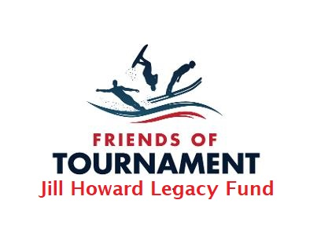
Jill Howard Legacy Fund
Jill sadly left us two years ago and as most of you will know she generously bequeathed a large sum of money to FoT. We have now received an interim payment from Jill’s estate of £140,000. The final amount is expected to be around £200,000. It was a poignant and sad moment when we received the first payment as we miss Jill and wish that she was still here with us. Our initial thinking is that we want to use this money for new initiatives apart from our core funding. We want to spend enough each year to support meaningful projects but also want the money to last for a considerable time. So our planned annual spend will be in the region of £15 – £17k. Jill was primarily a Waterski Official, an International Judge, Scorer and Homologator. She was a member of our Technical Committee and acted as a Trainer of new Officials. Jill loved to see youngsters developing and progressing into competitive Waterskiing.
If you have any thoughts on how we might use this money in ways that Jill would have appreciated please let us know.
Development Days 2023
FoT Development Days give the opportunity to young skiers who are not yet competing or have just started to compete to experience a day of focused high level coaching. All participants will be given a free British Competition Licence after the event. This year we are grateful to Glen Campbell who will be coaching at many of the events and Midlands Nautique who will be supplying a boat for some events.
Nine Development Days are on the calendar so far this year and the first six have already taken place. Details of each event with an Event Bulletin can be found in the IWWF Event Management System (EMS). https://ems.iwwf.sport/ or on the Events page on the BWSW Website.
The D Days completed so far this year have been fully subscribed and vey successful. We have seen a number of youngsters go over the ramp for the first time and get onto Trick skis.
- April 11th Tuesday - OWSC - Steve Glanfield
- April 29th Saturday - Cotswold - Meg Stowe
- May 14th Sunday - Town Loch - Chris Heron
- May 20th Saturday - Llangorse - TBC
- May 21st Sunday – Lound - Marc Grinhaff
- June 2nd – Tallington – Glenn Campbell
- June 24th - Ellingham - James Winwood
- August 2nd Wednesday – Rickmansworth - James Timothy
- August 8th Tuesday – OWSC – Steve Glanfield

The National Championships will feature a Development Days Youth Festival.

Backyard Events 2023
There are 13 Backyard Events on the calendar this year and are a great way for youngsters to start competing. FoT wants to encourage more grassroots competitions are this year are supporting all the Backyard events with £300 of support, to help make them a great success. This support is in the form of FoT merchandise for prizes or other practical way to assist the event.
FoT Promotional Merchandise
FoT has a range of merchandise including polo shirts, towels and baseball caps. These are all available for a donation to FoT. Suggested donations are Baseball Cap - £12, Polo Shirt - £25, Cotton Bath Sheet - £30 and Microfibre Bath Sheet - £25. Look out for them at future competitions. If you would like to get one of these please email Gavin Kelly for more information at gvnkelly@aol.com.
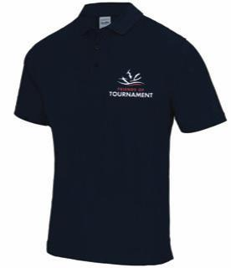

FoT Loan Kit
FoT also has a range of skis and other gear, largely donated by generous supporters, that is available for loaning out. We need to replenish stocks and if you have any kit, skis, ropes or handles you no longer need please consider donating them to FoT. Contact Dush or Gavin if you have anything to donate.
If you are thinking about starting to trick ski but are not ready to buy a ski FoT can loan you a ski. If ultimately you want to carry on we will help you source a ski to keep. If you want to borrow kit please get in touch with Dush at dushylukic@hotmail.com or Gavin at gvnkelly@aol.com.
We have a short pause on the loan kit scheme at the moment while we take an inventory check.

FoT Projected Spend 2023
There are two Youth Squad training camps taking place in July at JB Ski and PWTC (Hazelwoods) run by John Battleday and Charlotte Grant (Wharton). These are now fully booked by 2023 Squad Skiers

Thank you for reading and for supporting Friends of Tournament. If you have any comments about this newsletter or about the activities of FoT generally please get in touch. While FoT has a clearly defined remit as defined in it’s Terms of Reference we do want to hear from you if you have ideas for other initiatives or areas where we can provide support.
Gavin, Dusko and Stuart
FoT Committee

