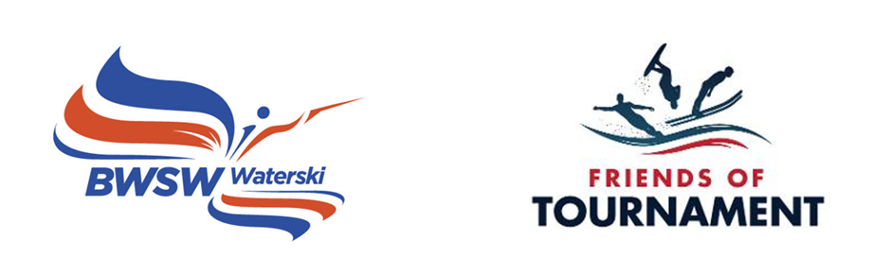

British Waterski & Wakeboard Federation Limited (BWSW) Friends of Tournament Committee– Terms of Reference (revised following receipt of a legacy from Jill Howard)

Background
In 2016 an application was made under the Gambling Act 2005 for the registration with Runnymede Borough Council of a small society lottery known as the “200 Club” to be run by Friends of Tournament as a fund-raising initiative of the Tournament Waterski Committee of BWSW to support tournament water-skiing.

These terms of reference are intended to record the role of the Friends of Tournament Committee as a subcommittee of the BWSW Waterski Committee (previously known as Tournament Committee) and are supplemental to the general “Committee Terms of Reference” published on the BWSW website (from time to time).

In June 2023, Friends of Tournament received the majority of a legacy from Jill Howard’s estate (approximately £200,000) (the “Jill Howard Legacy Fund”). Under Jill Howard’s will the funds were bequeathed to Friends of Tournament of British Waterski & Wakeboard Federation (but made no stipulation as to how the legacy should be applied). It can be inferred, however, that she wished her legacy to be used for the stated aims of Friends of Tournament i.e. supporting high level competitive athletes in slalom, tricks and jump when competing abroad and developing and promoting the Waterski discipline generally. The Friends of Tournament Committee will administer the Jill Howard Legacy Fund separately from the funds raised through the 200 Club and other fund-raising initiatives. in accordance with these aims.

Appointment and Constitution of the Friends of Tournament Committee
The Friends of Tournament Committee (or FoT Committee) being a subcommittee of the BWSW Waterski Committee shall comprise of at least 3 members, not less than 2 of whom shall be drawn from the members of the Waterski Committee and, where possible, one further member with appropriate skills who is independent of and not on the Waterski Committee who will be drawn from the wider public.
The Waterski Committee (acting under its delegated authority from the board of BWSW) shall have the power of appointment and removal of members of the Friends of Tournament Committee. The Waterski Committee shall review the membership of the Friends of Tournament Committee not less than once in every three years to ensure that it is appropriately constituted.
Members of the Friends of Tournament Committee shall be appointed on a purely voluntary basis without remuneration or the ability to claim expenses out of funds raised by the 200 Club , more widely by the Friends of Tournament Committee or the Jill Howard Legacy Fund. Reasonable amounts may be provided out the general funds of BWSW to meet expenses to the extent agreed with BWSW.
Decisions by members of the Friends of Tournament Committee will be made by majority vote (with no casting vote by the chairman of the committee).
The Friends of Tournament Committee shall meet regularly and report to the Waterski Committee, and when asked, the board of BWSW. The Friends of Tournament Committee shall (a) maintain a short written record of all decisions made which shall be made available to the Waterski Committee on an as required basis; (b) prepare a summary of income and expenditure to date prior to meetings of the Waterski Committee for consideration at such meetings distinguishing between the 200 Club and other initiative funds and the Jill Howard Legacy Fund and (c) prepare an annual income and expenditure account for publication to the members of the 200 Club/Friends of Tournament for (1) the 200 Club and other initiative funds and separately (2) the Jill Howard Legacy Fund

Friends of Tournament Committee Remit and Application of Funds
The Friends of Tournament Committee’s core remit shall be running the 200 Club in compliance with the Gambling Act and the literature provided to participants in the 200 Cub and otherwise fund-raising for the benefit of the Waterski discipline and the administration of the Jill Howard Legacy Fund as described below
Its prime aim shall be to raise/augment funds to support high level competitive athletes in slalom, tricks and jump when competing abroad and to develop and promote the Waterski discipline generally. Where possible the FoT Committee shall seek to minimise administration and promotion costs by obtaining sponsorship and/or support from the employed staff of BWSW. The Friends of Tournament Committee shall provide BWSW on a timely basis with all such information as may be required to comply with the Gambling Act 2005. BWSW will take responsibility for filing the resulting statutory returns.
The Friends of Tournament Committee shall be responsible for the distribution of funds raised through the 200 Club and other fundraising initiatives on a basis consistent with the above and within the following principles:-
- That funding shall augment and not replace any currently available funding.
- That approximately half the monies raised (after prize distributions) will support GB athletes competing abroad (Not 35+),
- That approximately half the monies raised (after prize distributions) will be used for the development of competitive water-skiing. Such development should not be limited to Squad & Development Days, but should also foster the growth of new generations of competition water-skiers through promotion of the ‘Cutting-Edge’ Programme, support for ‘Backyard’ competitions, Handicap Leagues, the provision of loan equipment (skis or tech kit) and other such initiatives.
- In the event of the 200 Club/ Friends of Tournament initiative being discontinued, any residual funds will be transferred to the Waterski Committee to support their existing activities.
Funds raised by the 200 Club and otherwise by the Friends of Tournament Committee (other than the Jill Howard Legacy Fund) shall be retained (until disbursed in accordance with these terms of reference) in a FOT designated BWSW bank account. Such funds will be included within the BWSW accounts in accordance with the relevant accounting requirements as a deemed restricted fund (or similar designation to comply with any audit requirements) to be applied (subject to insolvency law) solely for the benefit of tournament water-skiing Waterski.
The Friends of Tournament Committee shall be responsible for investing the Jill Howard Legacy Fund in accordance with a [low/medium risk strategy] or such other strategy as may be determined from time to time (taking professional advice where necessary). It is currently envisaged that between £12,000 and £17,000 will be distributed per annum on initiatives that the FoT Committee believe Jill Howard would have supported including the support and training of Officials and Youth Development.This will be solely on initiatives consistent with the stated aims of Friends of Tournament i.e. supporting high level competitive athletes in slalom, tricks and jump when competing abroad and developing and promoting the Waterski discipline generally. It is acknowledged that given that the likely yield will not be sufficient to cover the expected annual spend the Jill Howard Legacy Fund will have a limited life.
Funds will be retained (until disbursed in accordance with these terms of reference) in a FOT designated BWSW bank or bank accounts or other securities accounts. The Jill Howard Legacy Fund will be included within the BWSW accounts in accordance with the relevant accounting requirements as a long term deemed restricted fund (or similar designation to comply with any audit requirements) to be applied (subject to insolvency law) solely for the benefit of tournament water-skiing Waterski.

These terms of reference are approved by :

BWSW Waterski Committee : Date:
BWSW Board : Date

