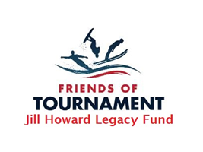
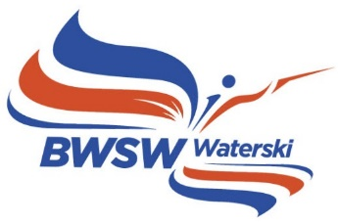
Jill Howard Legacy Fund Technical Grants 2024
There will be four grants of £500 available to clubs to upgrade or acquire technical kit required to host Competitions.
Clubs who are successful in getting these grants will be expected to host at least one Competition before the end of 2025. This can be a Backyard, Normal Homologation or Ranking List event and must be in addition to any other events planned by the club .

Equipment Needs
Specify the type of technical equipment the grant will be used for.

Budget Justification
Provide a breakdown of how the £500 will be utilised towards the acquisition of the technical kit.

Impact Statement
Explain how the new equipment will benefit the club and its members, such as improving safety, enhancing training opportunities, or expanding participation.

Long-Term Sustainability
Explain the club's ability to maintain and utilise the equipment effectively beyond the initial acquisition, ensuring a lasting impact.

Financial Need
Summarise the club's financial situation and whether the grant will significantly contribute to meeting its equipment needs.

Application Quality
Include supporting documents or testimonials, to assess the club's commitment and readiness to utilise the grant effectively.

Submitted on behalf of

…………………………………………………………by………………………………..………………………

Please return your application by 7th April 2024 to Gavin at gvnkelly@aol.com

