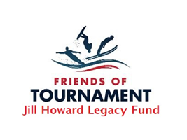

**The Jill Howard Legacy Fund**

**Youth Development Grants 2024**

|  |
| --- |
| **When applying for a support grant as a Development Day or U17 Squad Waterskier, key criteria includes:** |
| **Name : Email :** |
| **Competitive and Training Achievements**: |
| Demonstrate success in waterskiing competitions at Club, Backyard, Regional, National, International levels, or your participation and progress in FoT Development Days and Training Camps. |
| **Training and Development Plan**: |
| Outline a clear plan for how the grant will be used to enhance your skills, such as coaching, equipment upgrades, or participation in training camps. |
| **Financial Need**: |
| Providing information on your financial situation and how the grant would alleviate financial barriers to pursuing waterskiing opportunities. |
| **Commitment to the Sport**: |
| Show your dedication to the sport through consistent training, participation in events, and involvement in the waterskiing community. |
| **Academic and Personal Accomplishments**: |
| Highlight your academic achievements, leadership skills, and community involvement to demonstrate a well-rounded character. |
| **Future Goals**: |
| Articulate your long-term aspirations in waterskiing and how the support grant will contribute to achieving them. |
| **References and Recommendations**: |
| Include endorsements from coaches, mentors, or other influential figures in the waterskiing community to validate your potential and commitment. |

Submissions must be sent to [s.g.hills@btinternet.com](mailto:s.g.hills@btinternet.com) by 7th April 2024