**IWWF Event Management System (EMS) 2025**

EMS is the international booking system for all water ski competitions. All countries now use it, and every UK competition is listed on it along with Development Days and Squad training.

Once you’ve registered, you will have an opening page – see below. From this page you can purchase your IWWF license, as well as enter competitions. For registration each skier needs to have a dedicated email, families cannot share.

At the moment EMS doesn’t take payment, so you must contact the lake to arrange payment. Some lakes, like PWTC, have an online system for entry.

You must also have a BWSW license to compete in Rankings competitions. The EMS system allows you to book without a BWSW license as it’s not set up for National Licenses, however you cannot ski in a UK Ranking competition without a BWSW license. Get yours here: <https://www.bwsw.org.uk/home/>

If you need any help with registering, please contact Kylie at head office who should be able to help. kylie@bwsf.co.uk

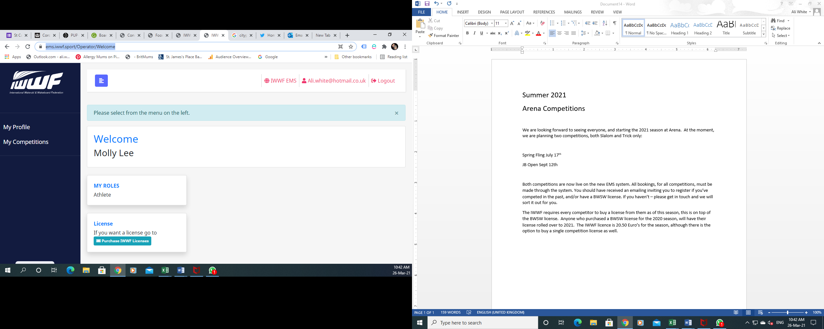

You will then see a screen with a variety of filters, choose **Waterski**, the dates you’re interested in, and **Great Britain** as the country. Hit **Search** and all UK competitions past the date you chose will show.

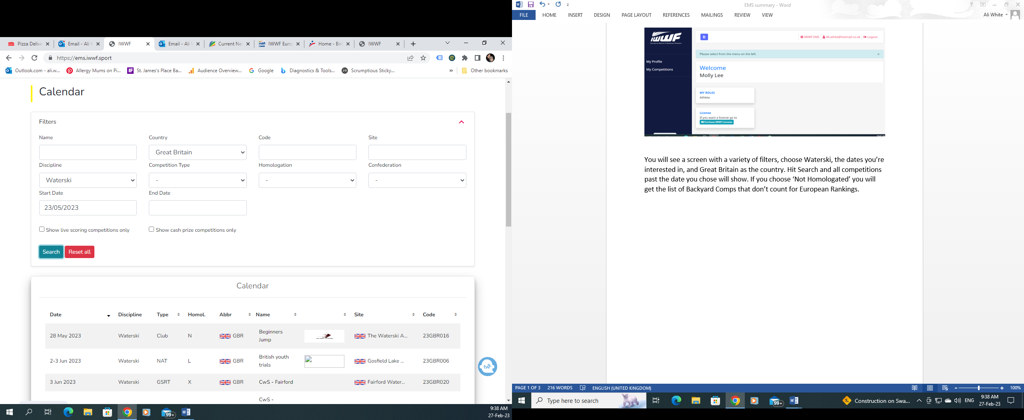

If you are looking for International Competitions you can leave the country blank, or choose the country you are interested in.

If you choose ‘**Not Homologated**’ you will get the list of Backyard Comps that don’t count for European Rankings (see below)

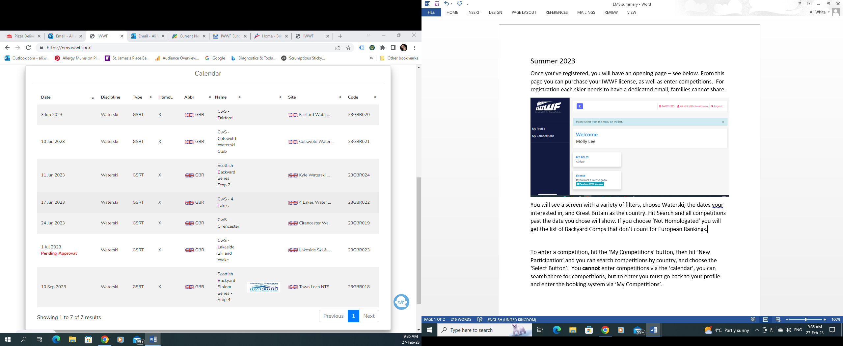

Competition Types comes in the following different types –

GSRT – Grass Roots (Non Ranking)

National – only open to skiers from that country (Ranking)

International – Open to skiers from all countries (Ranking)

Normal Homologation – Rankings but with limited scores.

NatCH – National Championships – some of these are open to skiers from other countries (Ranking)

The IWWF licence is not required for Development Days, Backyard, or Normal Homologation – only Rankings. You do not need a BWSW license to take part in Development Days but you do need a BWSW license to compete at any level.

When you click on the competition the details will show – including number of rounds, disciplines and age groups the competition is for.

To enter a competition, click on **My Competitions,** and then click **‘New Participation’,** again use the filters to avoid seeing every competition in the World. Hit the **Select** Button, and you will see the details. The system will automatically load your age group, and a list of events. Tick which ones you wish to enter, and then hit ‘**Submit Participation’.**

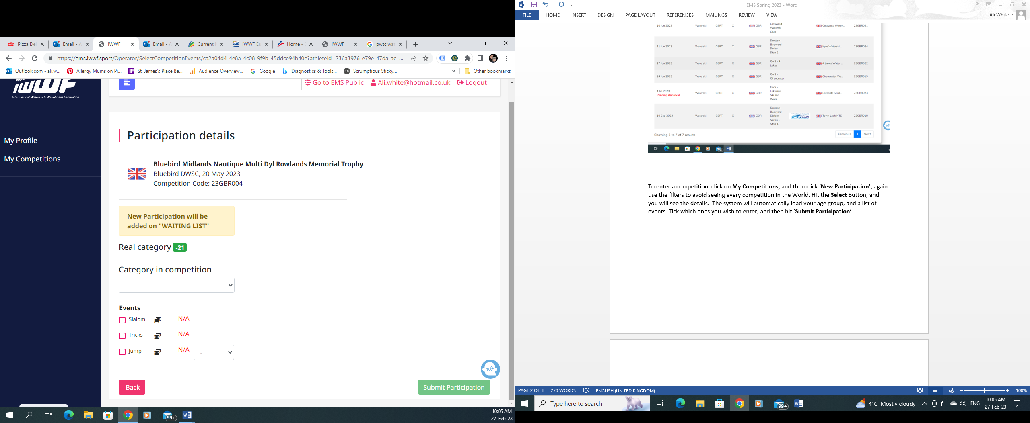

Once you’ve entered, you will see ‘Accepted’ under Participation Status. At this point in time, there is no email confirmation of entry. I take a picture or screenshot to keep as confirmation in case of any issues. The system will also flag if a competition is full with the option of a waiting list.

Competition fees need to be paid to the lakes, as per normal.

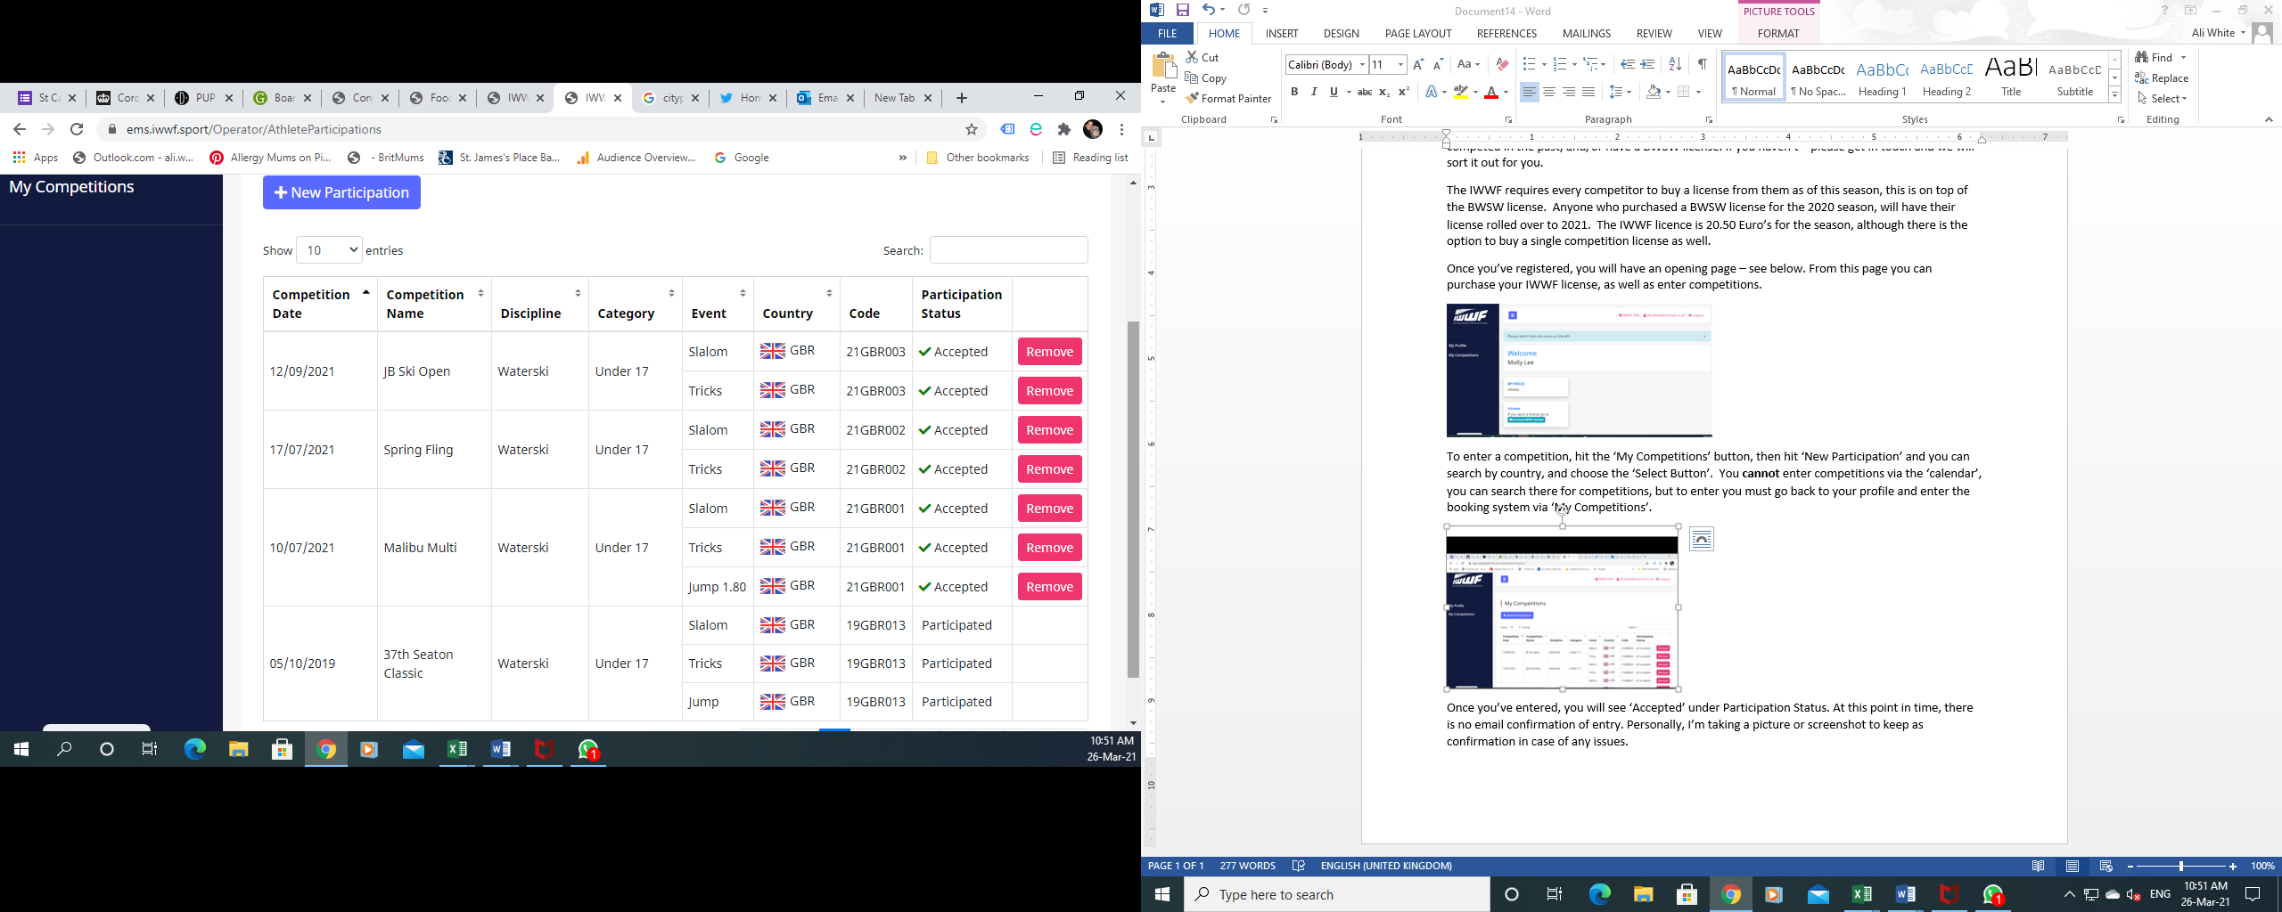

**Competition Details**

On the calendar when you see the list of competitions you can get more details by clicking on the competion name, in the example below, ‘Malibu Spring Multi’. You’ll then see a page with all the details regarding age categories, events, judges, drivers and homologators. Most importantly, you’ll also see the contact details for the organizer should you wish to get in touch prior to the competition to arrange practice sets.

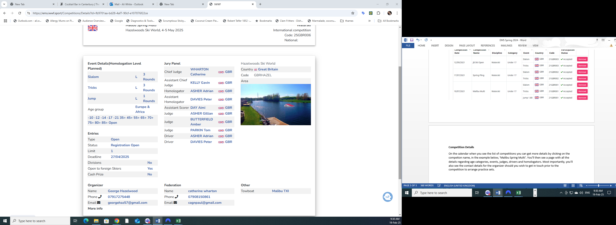

**Summary**

We hope that you find this document helpful when navigating EMS, should you have any questions please feel free to contact Ali White on 07921844682 or [ali.white@hotmail.co.uk](mailto:ali.white@hotmail.co.uk) who will be happy to talk through how to use the system (for Ali phone is preferable to avoid emails getting caught in the spam filter on hotmail). Alternatively contact Dush Lukic from the FOT Committee at [duskolukic05@gmail.com](mailto:duskolukic05@gmail.com) or on 07587554763.