2025 British National Youth Festival
sponsored by
Friends of Tournament
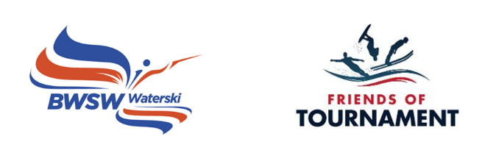

Bulletin British National Youth Festival 1st^{th} August 2025
Lound Water Ski Club, Chainbridge Lane, DN22 8RU
WHAT3WORDS:daunted.grert.hunches
Skier Briefing 8.00. Skiing Commences 8.30 and scheduled finish 17.30.

Points of contact on the day:
Dush Lukic 07587 554763 – dushylukic@hotmail.com and
M Grinhaff 07866 499 750 marc@grinhaff.com
Please download the attached booking form, complete, and send to: BWSW info@bwsf.co.uk . Instructions for payment are included in the booking form.
Closing Date for entries 25th July 2025

Entry Criteria - U18 D-Day Participants and those grass roots skiers not slaloming in actual National Championships
Skiing Disciplines – Slalom Only
Rules – 6 passes max, normal slalom rules.
Non course runners:
Age & Skier Categories - As above and includes a Novice Category for non-slalom course skiers.
Cost - £20
Licence Requirements - None
Facilities/Activities/Events – Camping/
Host Club Lound Water Ski Club
Organisers: Dush Lukic & FoT
Facilities: Camping, clubhouse and on-site catering facilities are available Camping (no electric plug in): Contact Marc Grinhaff
Accommodatin nearby - Bluebell Inn, Lound, Best Western Retford, The Boat Inn Hayton, Stonelake Lodges

Please note there will be a grassroots tournament on the Saturday for children and adults which you are welcome to enter - book via EMS

The National Youth Festival and FoT Development Days are organised by volunteers and funded by sponsors. Friends of Tournament rely entirely on fund raising, our main initiative is ‘The 200 Club’, a small lottery. The details of this can be found on our website: http://www.tournamentwaterskiing.org.uk/200-club/

