British National Youth Festival Lound - 1st August 2025
BOOKING FORM
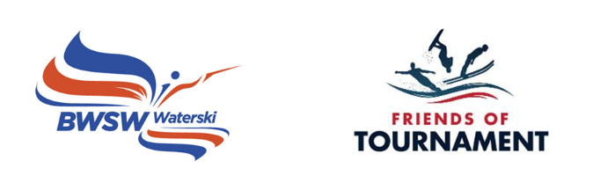

Skier Name |  | Surname
DOB |  | Gender
Club |  | Coach
BWSW membership |  | Address
Emergency contact |  | Relationship to skier
Emergency telephone |  | Email

Please make us aware of any relevant medical information/allergies.

Slalom

Personal Best in Practice

Personal Best in Grass Roots Events

Do you require a tent/caravan spot on the Thursday night? (free of charge, but no electric hook up) YES/NO
Do you require a tent/caravan spot on the Friday night? YES/NO

Any dietary requirements?

Please confirm that you are happy to be contacted by email: Y/N
Please confirm that you are happy for photos of your child to be shared on social media: Y/N

Please download and send to BWSW info@bwsf.co.uk.
Closing date for entries 25th July 2025

Payment: The cost of the event is £20.00 to be paid to BWSW Friends of Tournament.
Account Name: British Waterski & Wakeboard Federation Limited
Sort Code: 30 84 23 Account Number: 25491760 Reference: surname-Lound YF

Signed by parent/guardian:
Print:
Date:

